

**v4.x CertScan Installation on Kubernetes Environment**

Manual prepared for:

S2 Support and Implementation Team

Submitted on: **Jan 2024**



|  |  |
| --- | --- |
| S2 Global, Inc.  1800 Eller Drive, Suite 400  Fort Lauderdale, Florida 33316 USA |  |

Information Statement

**Copyright Notice**

Copyright © 2024 S2 Global. All rights reserved. No part of this document may be reproduced, transmitted, transferred, modified or translated, in any form or by any means, without the express written permission of S2 Global.

**Proprietary Information Notification**

This document and the information contained herein proprietary to S2 Global and is protected by all applicable laws throughout the world. Any use, disclosure or duplication of this document or any information contained herein is strictly prohibited, except to the extent expressly agreed to in writing in advance, in each instance, by S2 Global.

**Trademark Notice**

S2 Global, CertScan®, Rapiscan®, AS&E®, Eagle® and other trademarks that may appear throughout this document are owned by S2 Global or its affiliates and are used to distinguish its/their products in the United States and other countries throughout the world. Unauthorized use of any such trademarks is strictly prohibited.

**Content of this Document Statement**

S2 Global has endeavored to ensure that the information in this document is accurate and complete as of the date of creation. Through its provision of this document, S2 Global provides no warranties of any kind, and to the maximum extent permitted by applicable law disclaims all warranties, express, implied or statutory, including, without limitation, any implied warranties of merchantability, fitness for a particular purpose, title, non-infringement or accuracy, and any warranties that may arise from course of dealing or performance or usage of trade.

Table of Contents

1. General Support Information 1

1.1 Purpose 1

1.2 Scope 1

1.3 Intended Audience 1

1.4 Software Requirement 1

1.5 Hardware Requirement 2

1.6 Pre-requisites 2

2. CertScan Installation 3

2.1 Kubernetes Cluster Installation Process 3

2.1.1 Virtual Machine Setup 3

2.1.2 Use PuTTY to connect with VMs 4

2.1.3 Update VMs with latest Package(s) 5

2.1.4 Disable Swap and Enable IP Forwarding 6

2.1.5 Install Docker CE 9

2.1.6 Add Kubernetes Repository 23

2.1.7 Install Kubernetes Components 27

2.1.8 Initialize Kubernetes in Master Node 33

2.1.9 Deploy a Pod Network 36

2.1.10 Join Worker Nodes into Kubernetes Cluster 37

2.2 ÀWS CLI Installation & Setup 38

2.3 AWS Configuration 41

2.4 Access Docker with AWS ECR 42

2.5 NFS Server and Client Setup 43

2.5.1 NFS Client Setup 47

2.6 Deploy CertScan Application 48

2.6.1 Preliminary Actions 48

2.6.2 Deployment of CertScan application 51

2.6.3 CronJob Setup 55

2.6.4 Access CertScan Application 56

3. Logging and Monitoring (Visualization) 58

3.1 EFG (ElasticSearch, FluentBit, and Grafana) 58

4. Certificate Update Process 66

Revision Record

| Rev. | Description | Author | Date |
| --- | --- | --- | --- |
| 1.0 | Draft Release | Maruthi | Mar 2023 |
| 1.1 | Updated the priliminary actions and the deployment procedure in **Section 2.6** | Maruthi | Jan 2024 |
|  |  |  |  |

Glossary & Acronyms

|  |  |
| --- | --- |
| **Acronym** | **Definition** |
| APT | Advanced Package Tool |
| AWS | Amazon Web Services |
| CLI | Command Line Interface |
| ECR | Elastic Container Registry |
| HDD | Hard Disk Drive |
| LTS | Long Term Support |
| NFS | Network File System |
| OS | Operating System |
| VIM | Vi IMproved |
| VM | Virtual Machine |

1. General Support Information
   1. Purpose

This document describes about the CertScan Installation procedure on Kubernetes environment with three node cluster (1 Master and 2 Worker Nodes) having Linux (Ubuntu 20.04 LTS) Operating System.

* 1. Scope

This document covers CertScan v4.x.x Installation procedure using Kubernetes Cluster in Linux server.

**IMPORTANT:** This document is for internal use only and not for the external use**.**

* 1. Intended Audience

This document is intended for the internal user(s) like **S2 Global IT**, **S2 Global Customer Support**, and **S2 Global Engineering Teams** to install CertScan application on Kubernetes Cluster environment.

* 1. Software Requirement
* 4 Virtual Machines
  + 3 VMs are configured as Kubernetes Cluster nodes (i.e., 1 Master and 2 Worker Nodes)
  + 1 VM is configured as NFS Server.
* Open Secure Shell (openssh-server)
* CURL & VIM
* PuTTY
* Docker CE
* AWS CLI Setup
* WinSCP
  1. Hardware Requirement

The procedure in this document is tested on 3-node Kubernetes Cluster and NFS Server virtual machines with the following configuration:

|  |  |  |  |
| --- | --- | --- | --- |
| Virtual Machines | RAM | CPU | HDD |
| Kubernetes Master Node | 32GB | 6+ Core | 200GB |
| Kubernetes Worker Node | 32GB | 6+ Core | 200GB |
| Kubernetes Worker Node 1 | 32GB | 6+ Core | 200GB |
| NFS Server | 32GB | 6+ Core | 500GB |

* 1. Pre-requisites

The following are the pre-requisites that are required before performing the installation procedure:

* There should be 3 virtual machines running with Ubuntu 20.04 OS.
* A root password configured on each server.

1. CertScan Installation

This document is helpful for installing the CertScan v4.0.0 application on Kubernetes environment with three node cluster (1 Master and 2 Worker Nodes) having Ubuntu 20.04 OS.

**NOTE:** All the commands in this document are represented in **‘Courier New’** font. If any of the commands doesn’t work as expected (i.e., as shown in the screenshots), then please add **sudo** as a prefix to the command and execute them again.

* 1. Kubernetes Cluster Installation Process

A Kubernetes (k8s) Cluster is a grouping of nodes that run containerized applications in an efficient, automated, distributed, and scalable manner.

Following are the steps to be performed to setup the Kubernetes Cluster. A detailed explanation of each step is provided in this document.

1. Virtual Machine Setup
2. Use PuTTY to connect with the VMs
3. Update VMs with latest package(s)
4. Disable Swap and Enable IP Forwarding
5. Install Docker CE
6. Add Kubernetes Repository
7. Install Kubernetes Components (Kubectl, kubelet and kubeadm)
8. Initialize Kubernetes Master Node
9. Deploy Pod Network
10. Join Worker Nodes into Kubernetes Cluster
    * 1. Virtual Machine Setup

Each Kubernetes Cluster node must be setup on a Virtual Machine and contain a specific Username and Password to login to it.

**Note:** Following are the sample VMs used to demonstrate the 3-node Kubernetes Cluster in this document. Make sure to replace them accordingly with your respective VM’s IP addresses wherever it is applicable.

|  |  |  |  |
| --- | --- | --- | --- |
| Kubernetes Node | Username | VMs IP Address | Operating System |
| Master Node | labk8smasternode | 10.9.204.161 | Ubuntu 20.04 |
| Worker Node | labworkernode | 10.9.204.159 | Ubuntu 20.04 |
| Worker Node 1 | labk8sworkernode1 | 10.9.204.53 | Ubuntu 20.04 |

* + 1. Use PuTTY to connect with VMs

PuTTY application is used to connect with the Virtual Machines.

Follow the below process to connect with the VMs that are setup:

1. Open PuTTY application.
2. Enter the IP Address of the VM in **Host Name (or IP address)** field as shown below and click on **Open**.

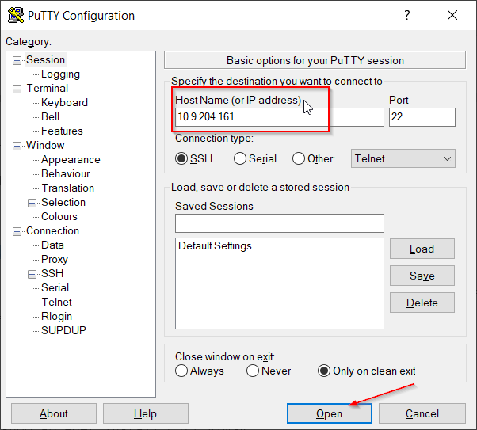

1. If you observe the below security alert, click on **Accept** to continue connecting with the VM.

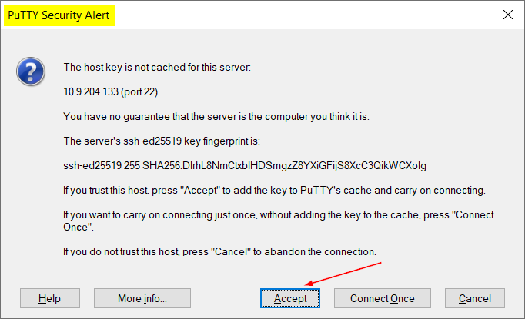

1. Provide the Username and Password associated with the VM.

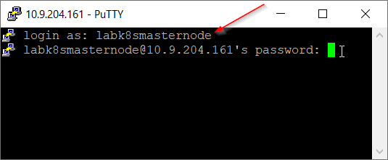

1. Click ENTER to login in to the VM.

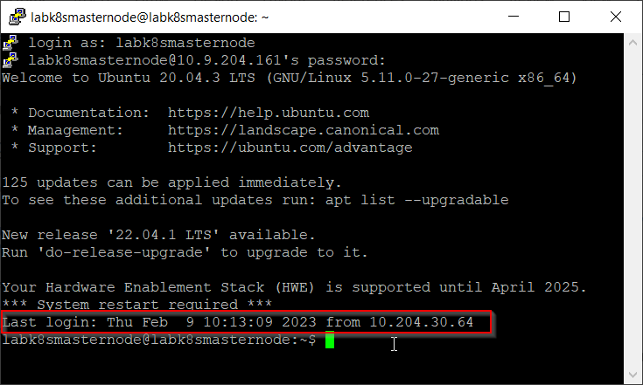

* + 1. Update VMs with latest Package(s)

To update the VMs with latest available package(s), run the following command on all nodes once the login is successful.

**sudo apt update -y**

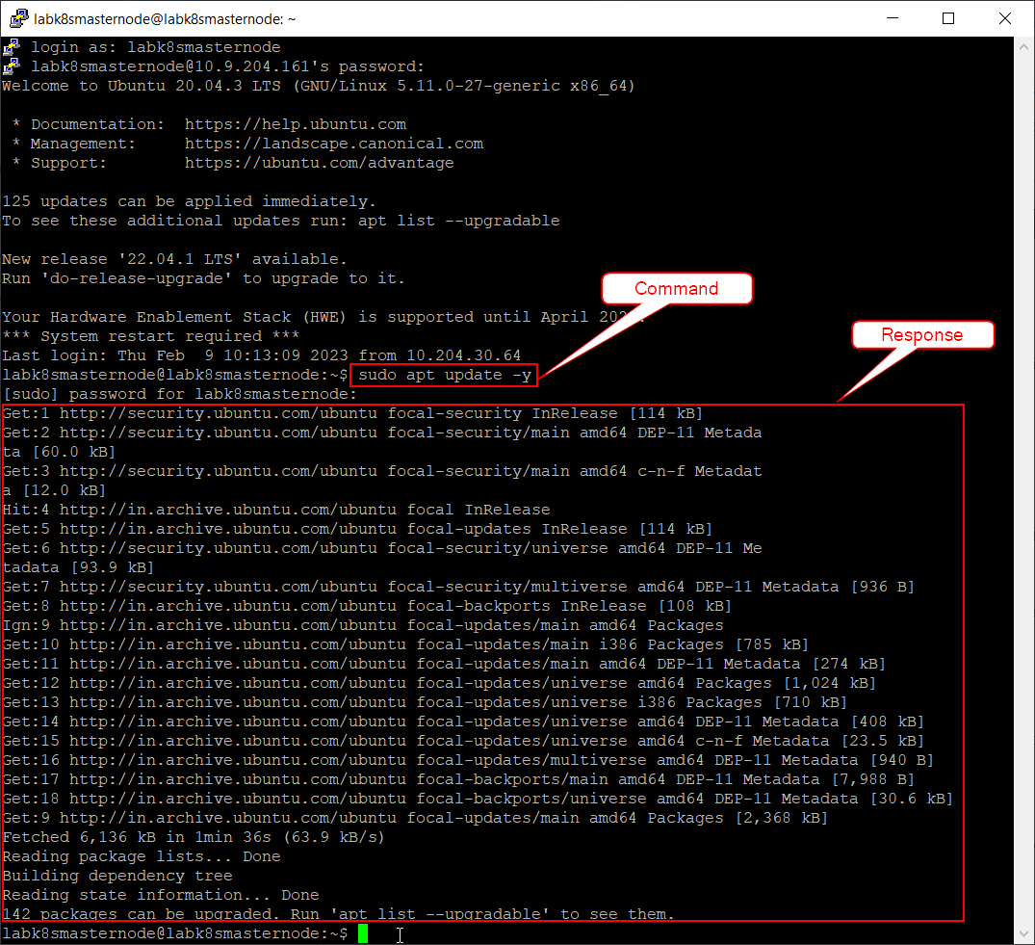

NOTES:

* This command will obtain the updated versions of packages (if available).
* It is always recommended to run this command before installing any package.
* It is mandatory to provide the password associated with the username whenever you run any **sudo** command either for the first time or after keeping the server in idle state for some time.
  + 1. Disable Swap and Enable IP Forwarding

It is recommended to disable Swap and enable IP Forwarding on all nodes. The major reason is that the memory swapping might cause performance and stability issues within Kubernetes.

**To disable the Swap:**

1. Run **sudo nano /etc/fstab** command to open the fstab file.
2. Place a comment (#) before the **swapfile** related information (as shown below) or remove the entire information.

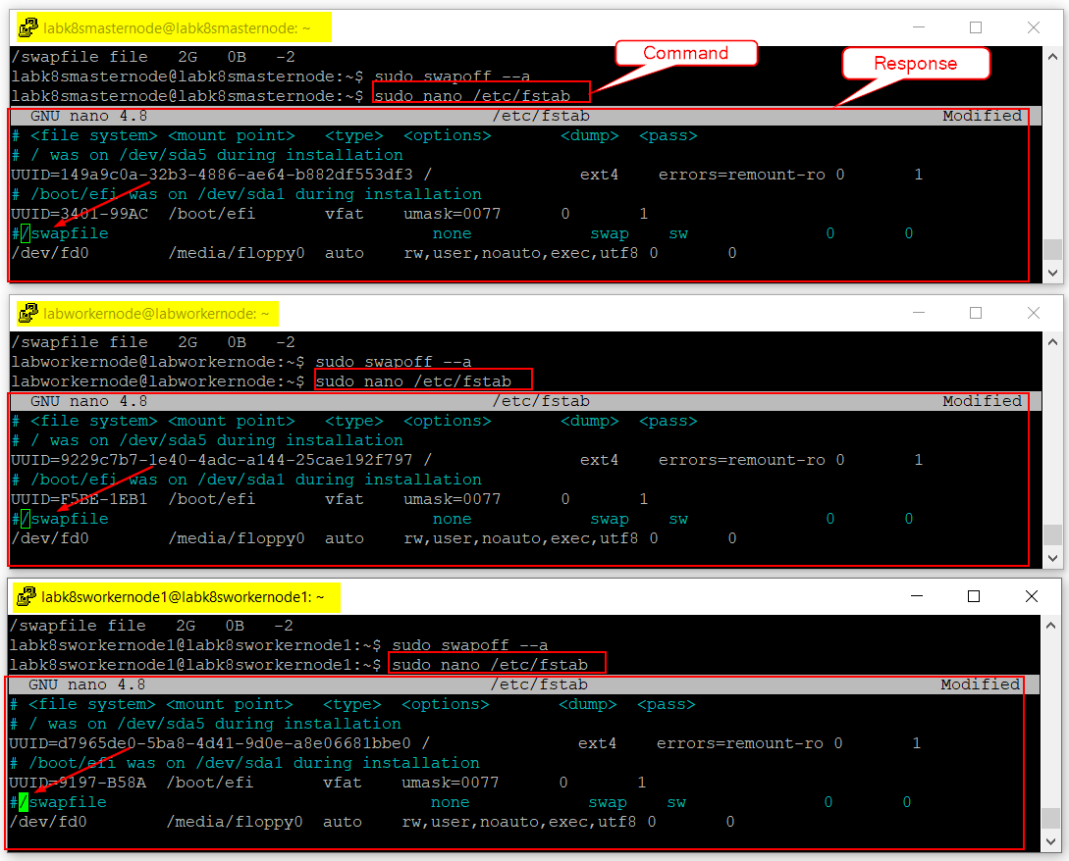

1. Save the fstab file by using the following commands.
   1. Click “Cntrl + O” to Write Out the changes and then press ENTER.
   2. Click “Cntrl + X” to Exit from the file.

**To enable the IP Forwarding:**

1. Run **sudo nano /etc/sysctl.conf** command to open the sysctl config file.
2. Search for the *“****net.ipv4.ip_forward=1****”* line and uncomment (remove #) it as shown below.

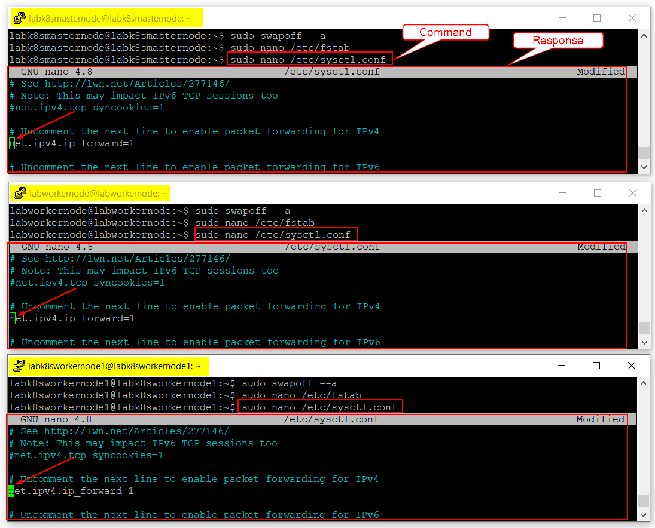

1. Save the sysctl.conf file by using the following commands.
   1. Click “Cntrl + O” to Write Out the changes and then press ENTER.
   2. Click “Cntrl + X” to Exit from the file.
2. Run **sudo sysctl -p** command to verify the applied configuration changes.

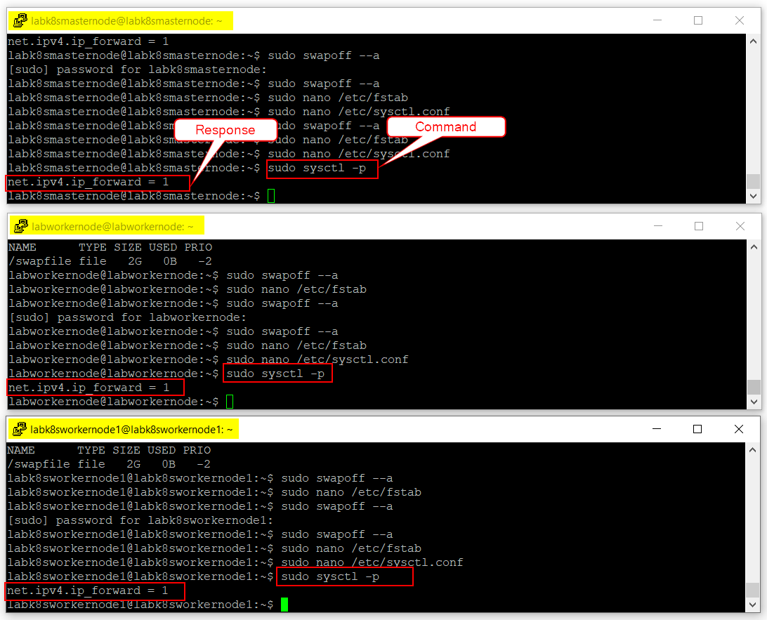

* + 1. Install Docker CE

Docker CE must be installed on all nodes because Kubernetes relies on a Docker container. By default, the latest version of the Docker CE is not included in the Ubuntu default repository, so it is required to add Docker’s official repository to the Advanced Package Tool (APT) library.

**To install and setup the Docker CE:**

1. Run **sudo su** command to login to root directory.

**NOTE:** The system may ask you for the password. If you know the password, then enter the password and access the root directory. Else, contact your System Administrator. **DO NOT RUN THIS COMMAND TWICE.**

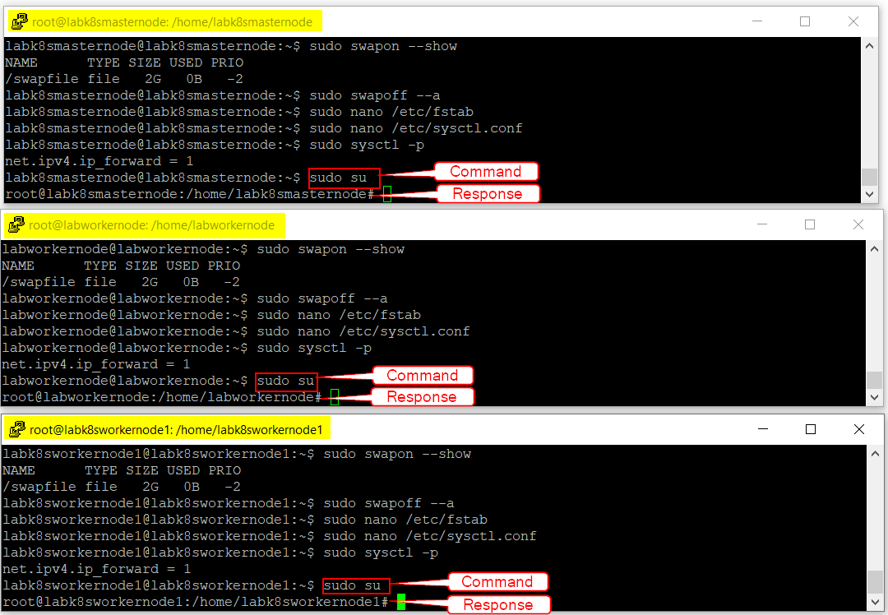

1. Run **sudo apt-get install apt-transport-https ca-certificates curl software-properties-common -y** command to install all the required dependencies for accessing Docker repositories over HTTPS.

***Master Node***

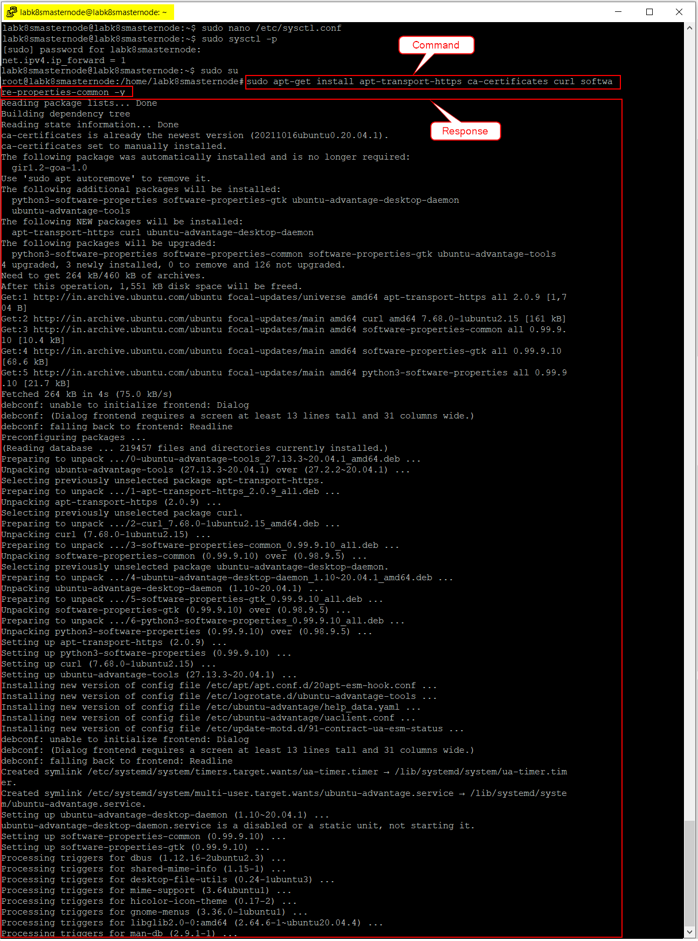

***Worker Node***

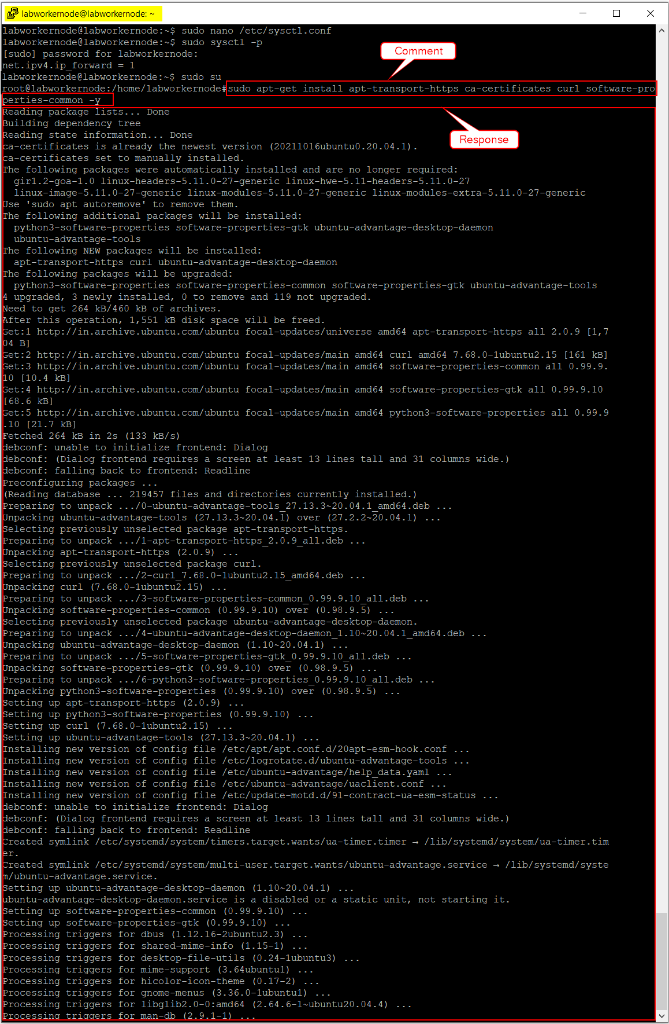

***Worker Node1***

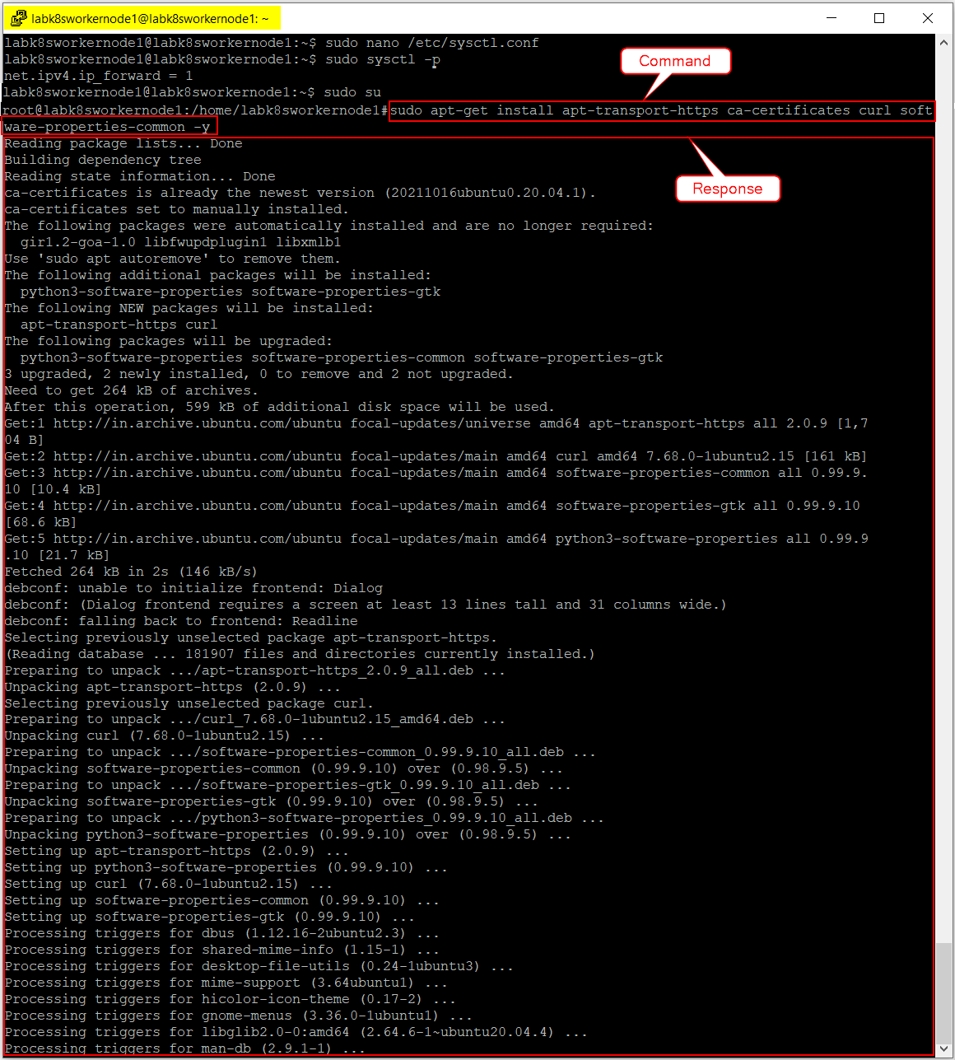

1. Run **sudo curl -fsSL https://download.docker.com/linux/ubuntu/gpg | apt-key add -** command to download the latest available Docker version and add its GPG key.

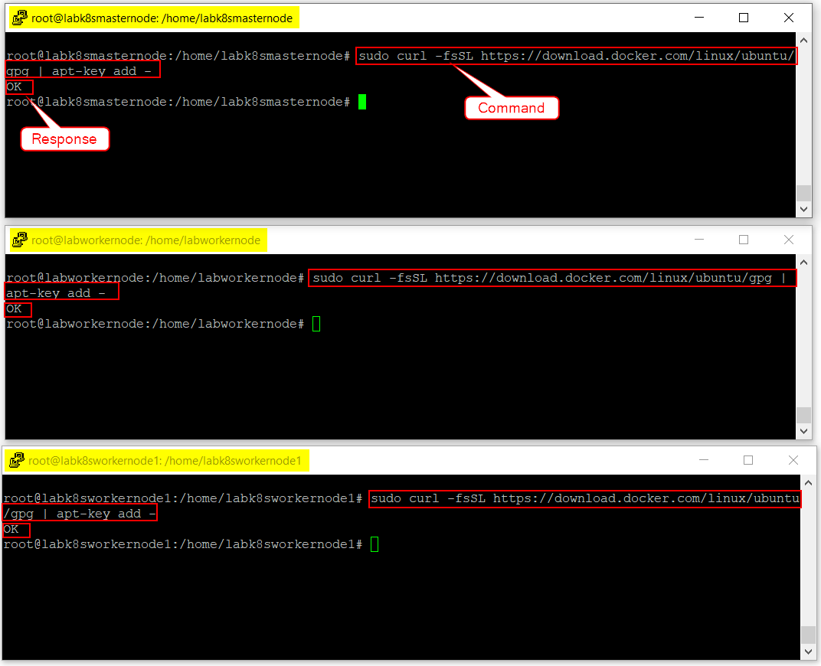

1. Run **sudo add-apt-repository "deb [arch=amd64] https://download.docker.com/linux/ubuntu $(lsb_release -cs) stable"** command to add Docker’s official repository to the APT.

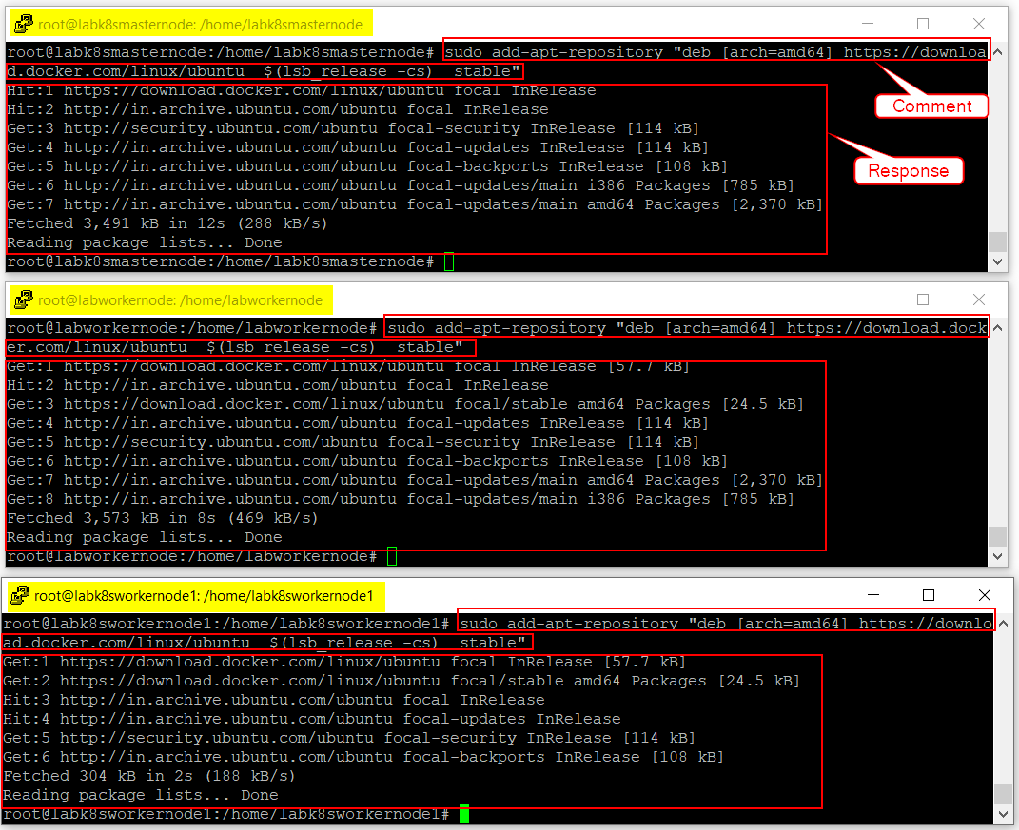

1. Run **sudo apt-get install docker-ce -y** command to install Docker CE.

***Master Node***

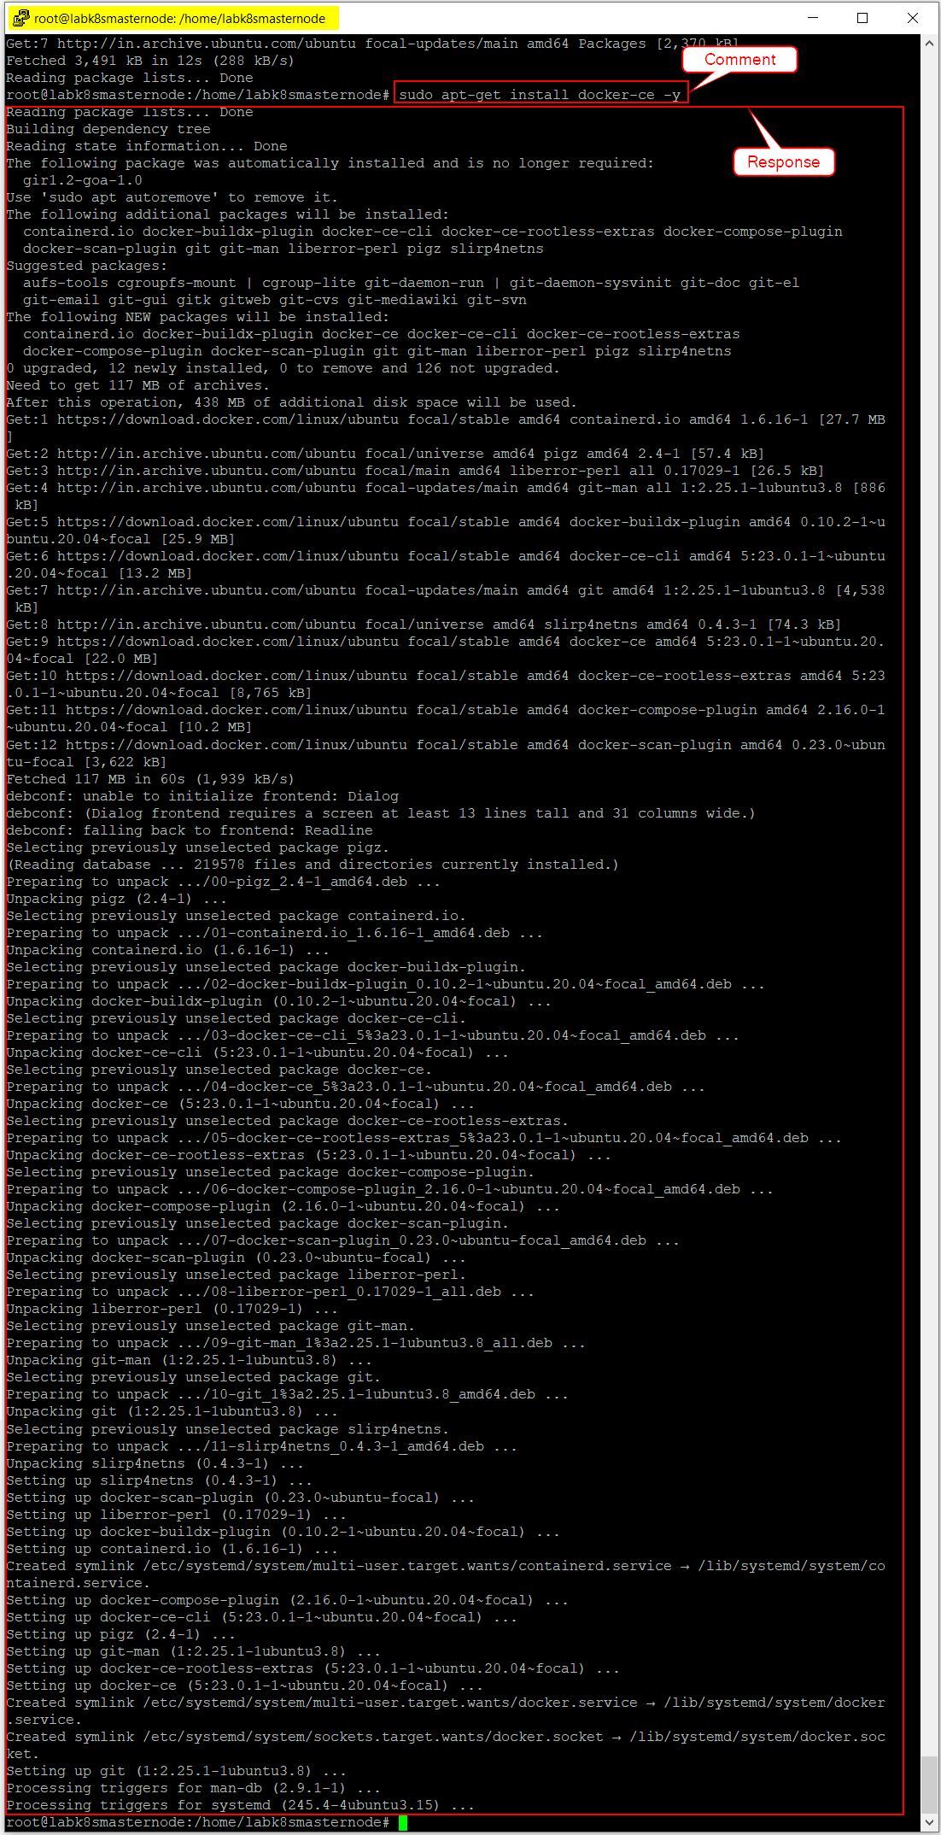

***Worker Node***

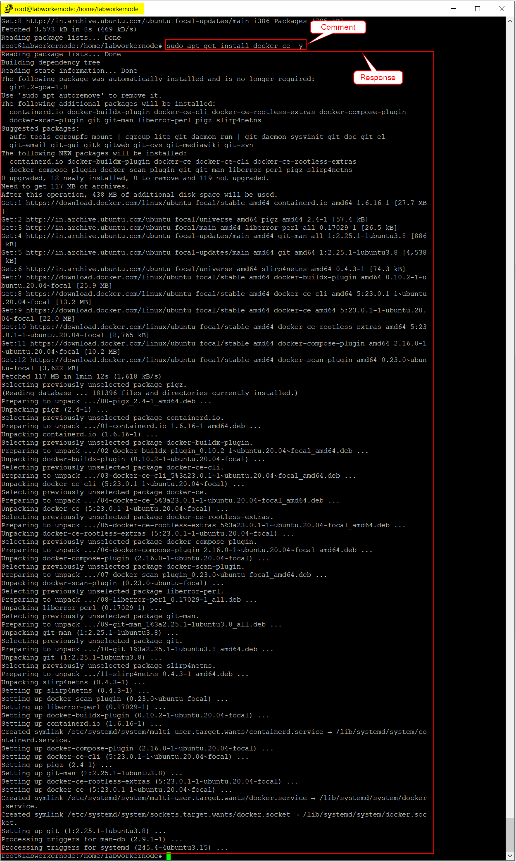

***Worker Node 1***

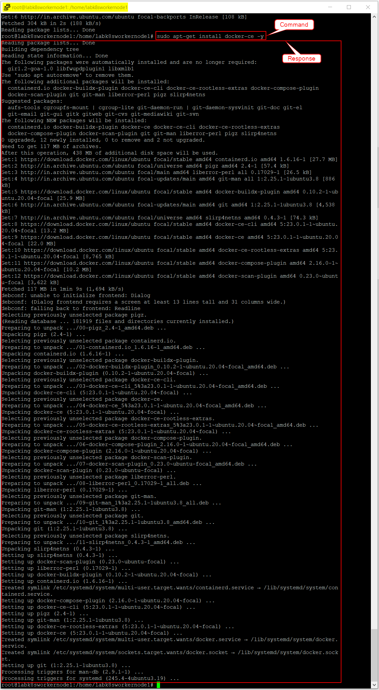

1. Run **sudo groupadd docker** command to create the Docker group.
   1. If a Docker group already exists, then the response will be displayed as shown below. Else, a new Docker group will be created.

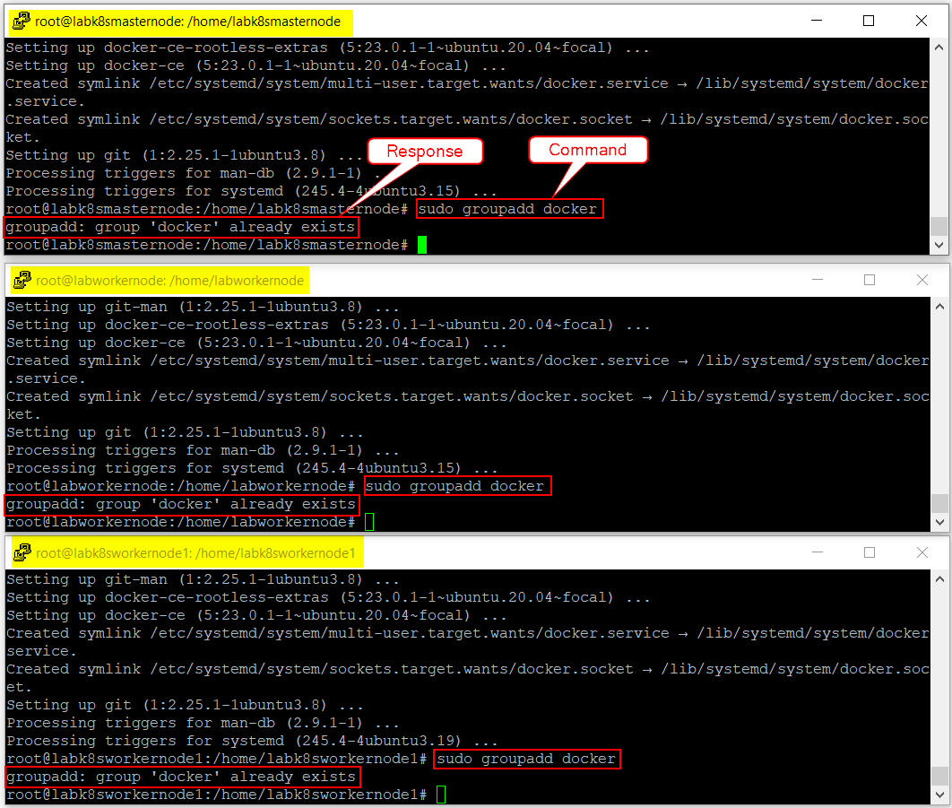

1. Run **sudo usermod -aG docker $USER** command to add a user to the Docker group.

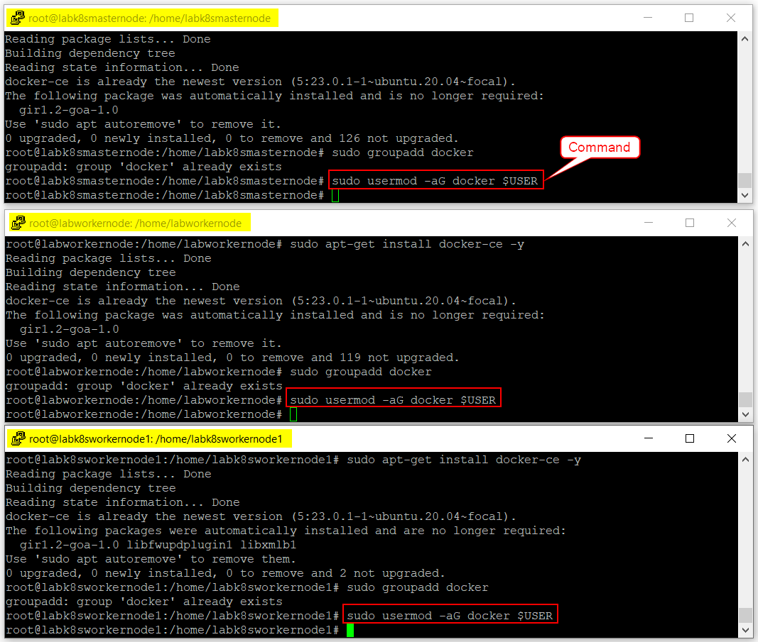

**Note:** If you’re running Linux in a virtual machine, it may be necessary to restart the virtual machine for changes to take effect.

1. Run **newgrp docker** command to activate the changes to the group.

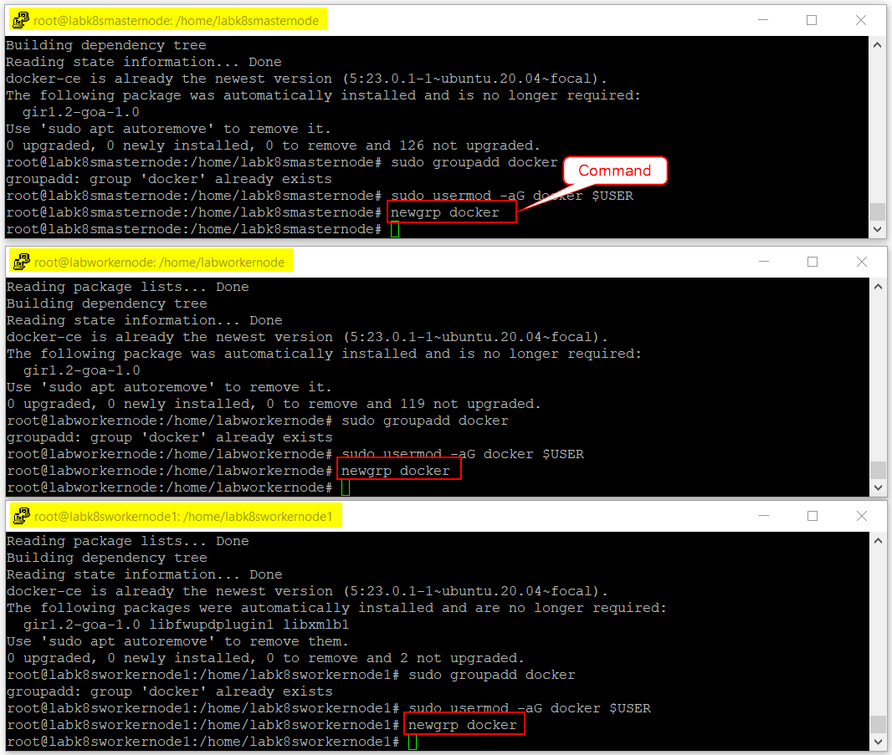

1. Run **sudo systemctl status docker** command to verify whether the Docker service is active or not.
   1. If active, then press **q** button on the keyboard to exit from the docker service file and perform **Step 10**.

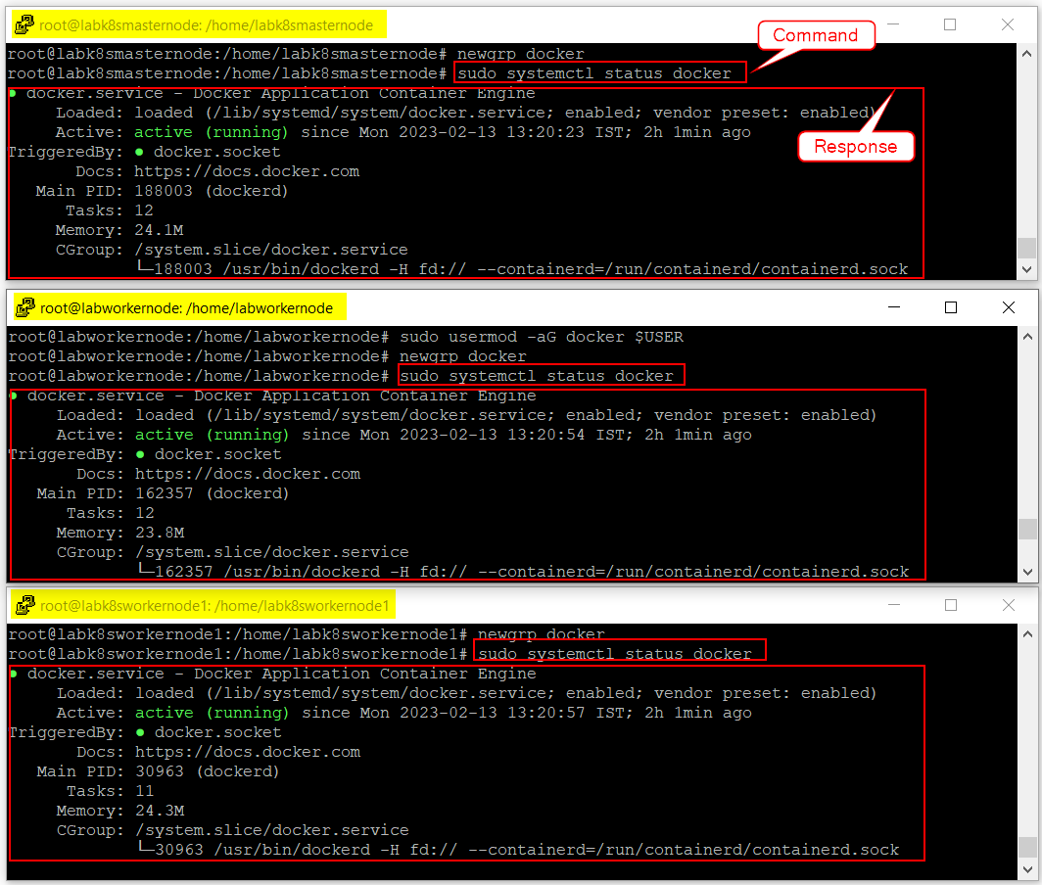

* 1. If inactive, then press **q** button on the keyboard to exit from the docker service file and perform the following steps.

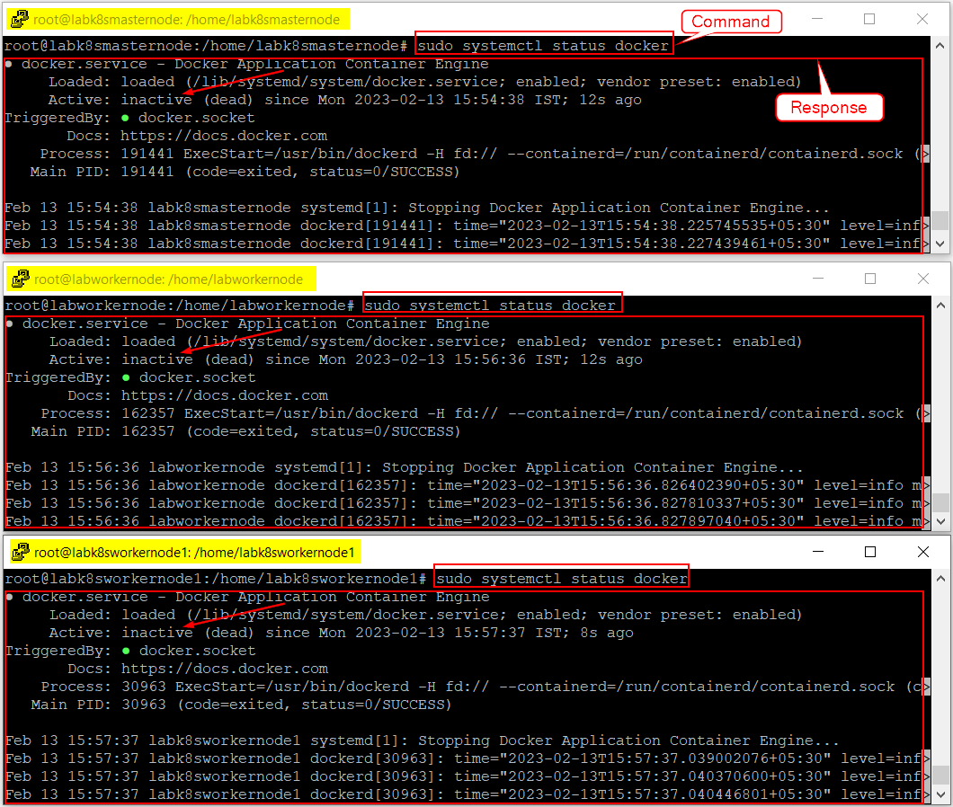

* + 1. Run **sudo systemctl enable docker** command to activate the Docker service.

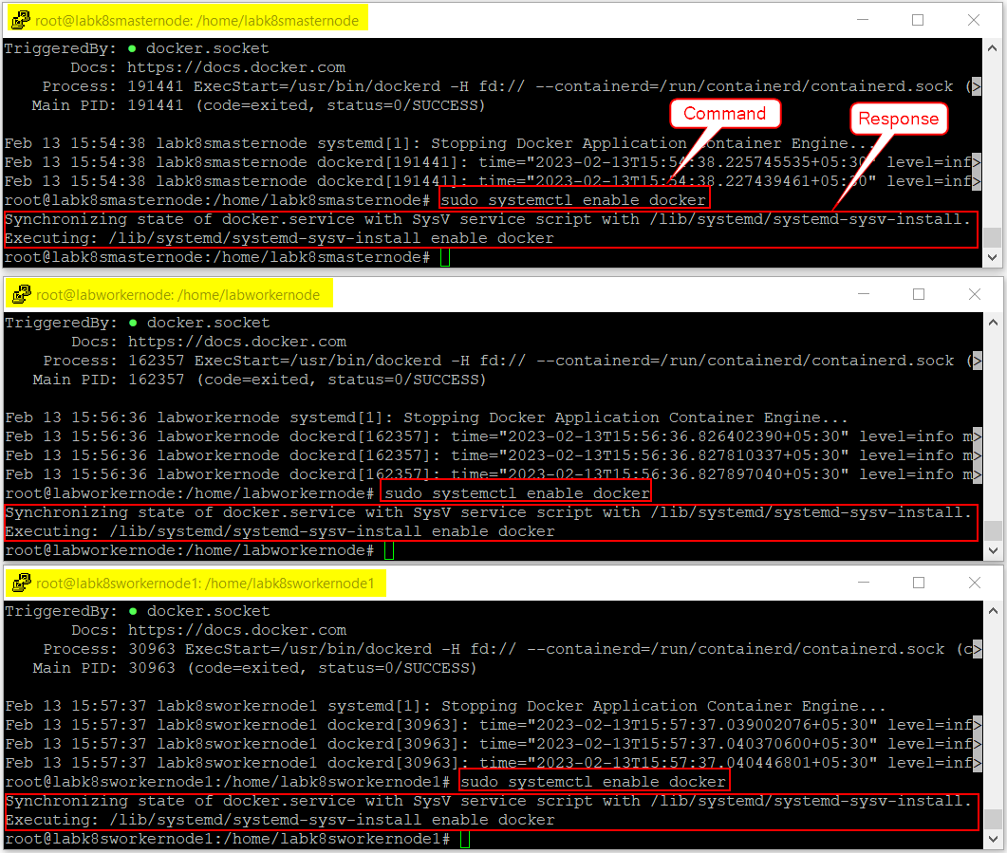

* + 1. Run **sudo systemctl restart docker** command to restart the Docker service.

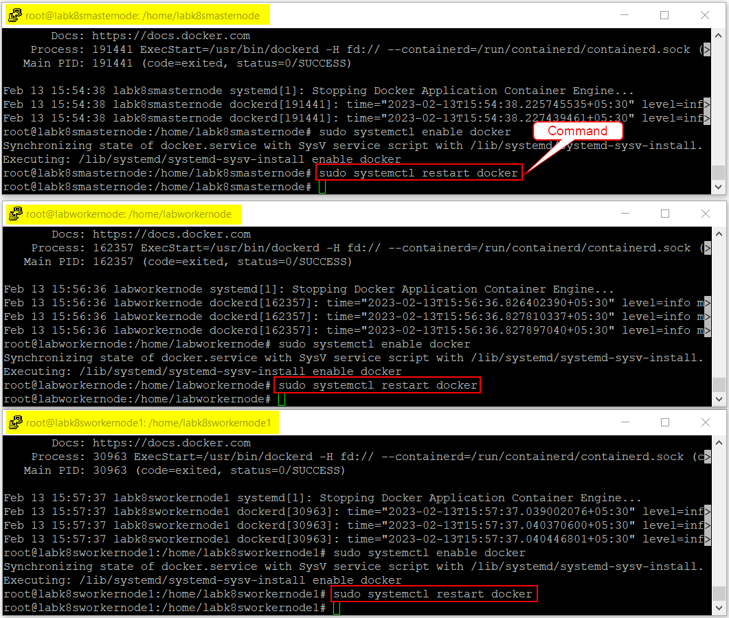

* + 1. Run **sudo systemctl reboot -i** command to reboot the Ubuntu server.

**Note:** Below screenshot is taken from Master Node. Make sure to repeat the same action in both Worker Nodes as well.

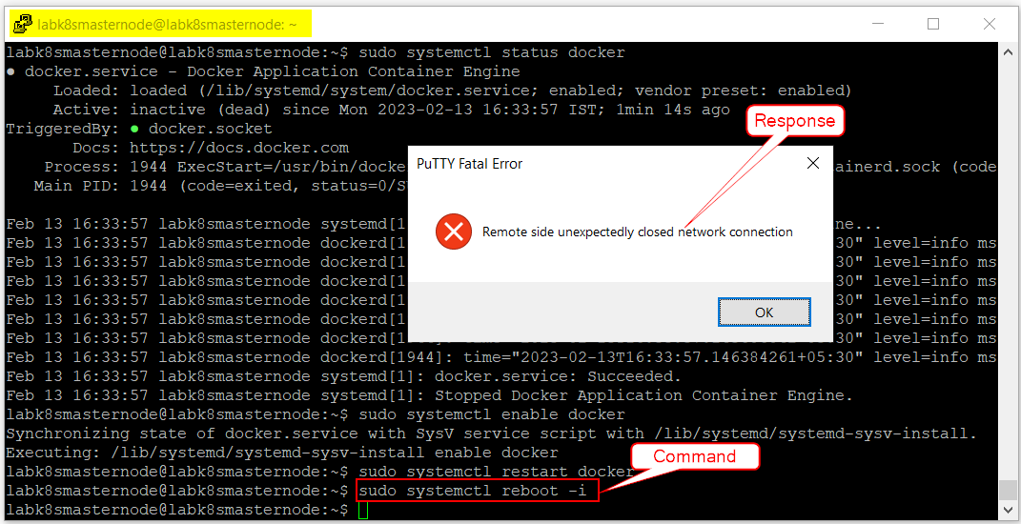

* + 1. Click on **OK** button and restart the session either by following the steps mentioned in **Section 2.1.2**or by right-click on the window header as shown below. Once the session is restarted, make sure to login to root directory.

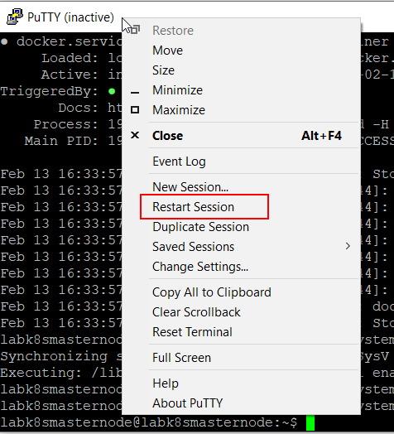

1. Run **docker --version** to verify whether the Docker is installed successfully.

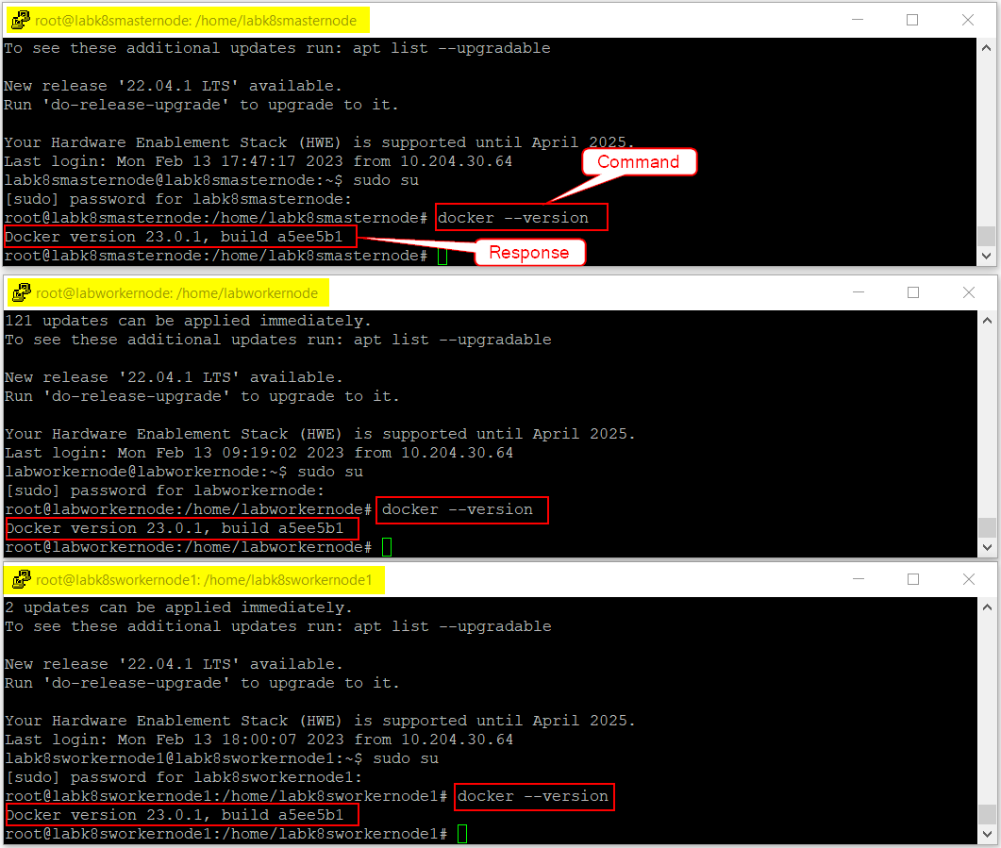

* + 1. Add Kubernetes Repository

By default, the Kubernetes package is not included in the Ubuntu default repository, so it is required to add Kubernetes repository to APT on all nodes.

**To add the Kubernetes repository:**

1. Run **sudo curl -s https://packages.cloud.google.com/apt/doc/apt-key.gpg | apt-key add** command to get the Kubernetes GPG key.

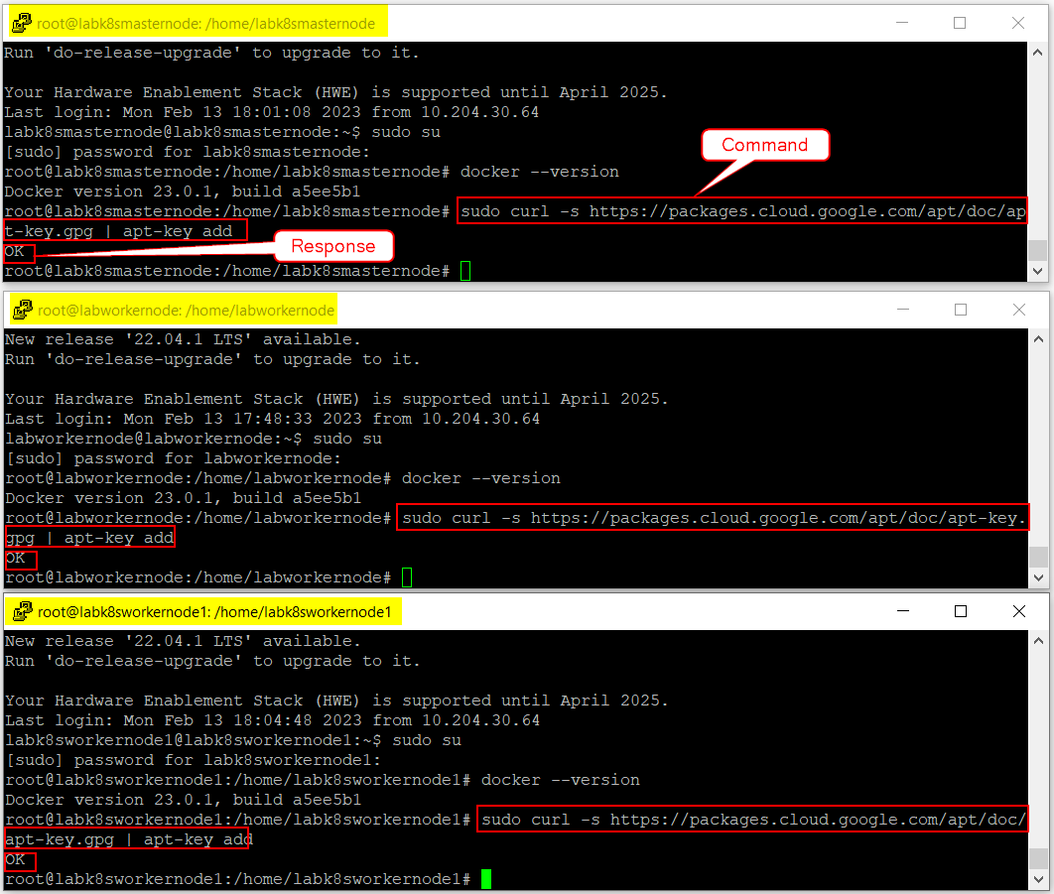

1. Run **sudo apt-add-repository "deb http://apt.kubernetes.io/ kubernetes-xenial main"** command to add the Kubernetes repository to the APT.

***Master Node***

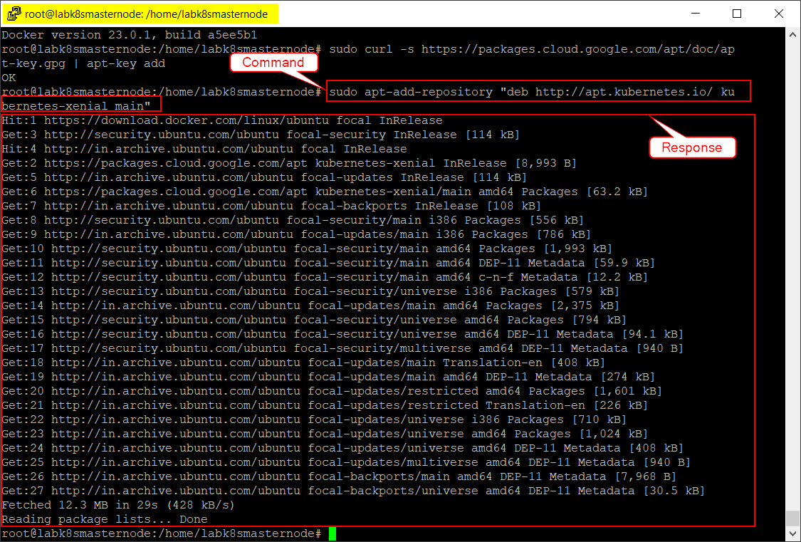

***Worker Node***

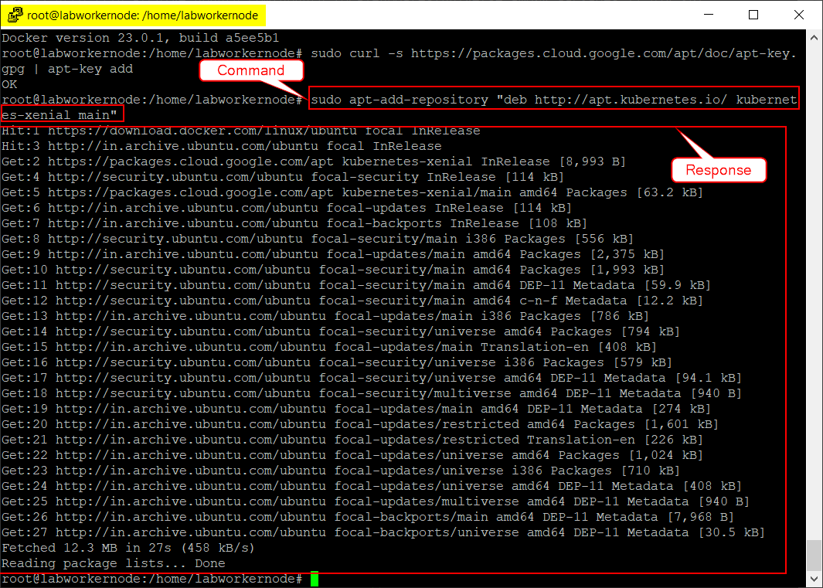

***Worker Node 1***

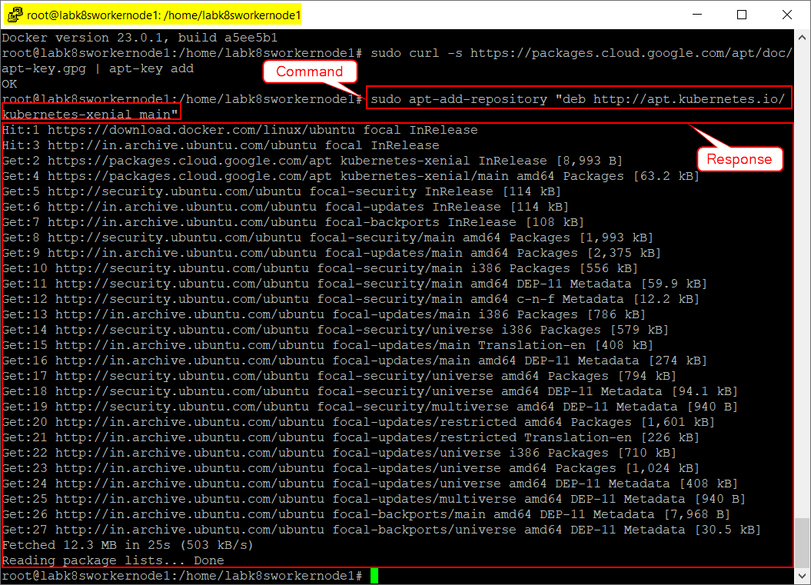

1. Run **sudo apt-get update -y** command to update the APT cache.

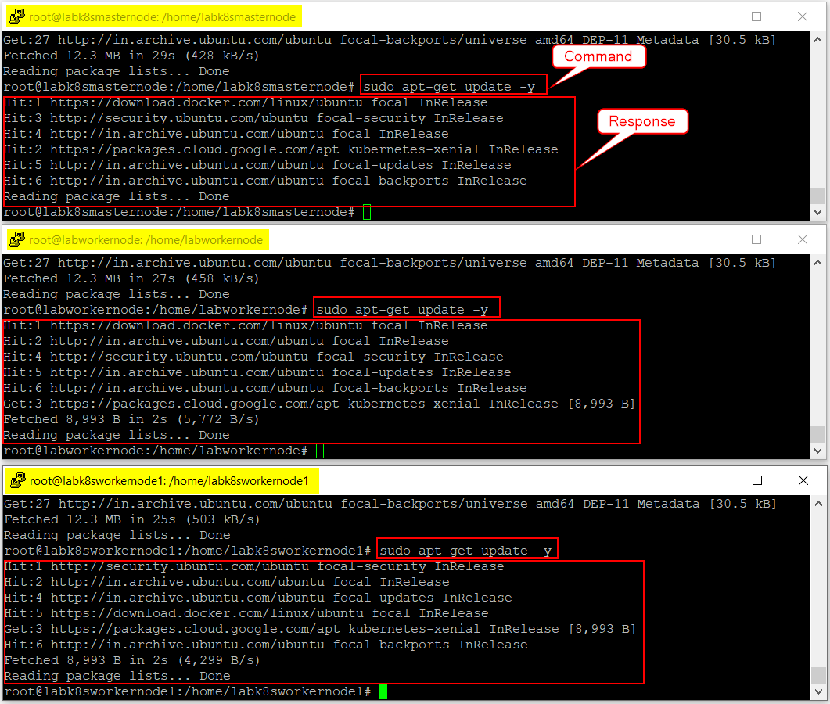

* + 1. Install Kubernetes Components

Kubernetes depends on three major components i.e., **Kubectl, Kubelet and Kubeadm** that make up a Kubernetes runtime environment. These three components must be installed on all nodes.

**To install the Kubernetes Components:**

1. Run **sudo apt-get install kubelet kubeadm kubectl -y** command to install all Kubernetes components.

***Master Node***

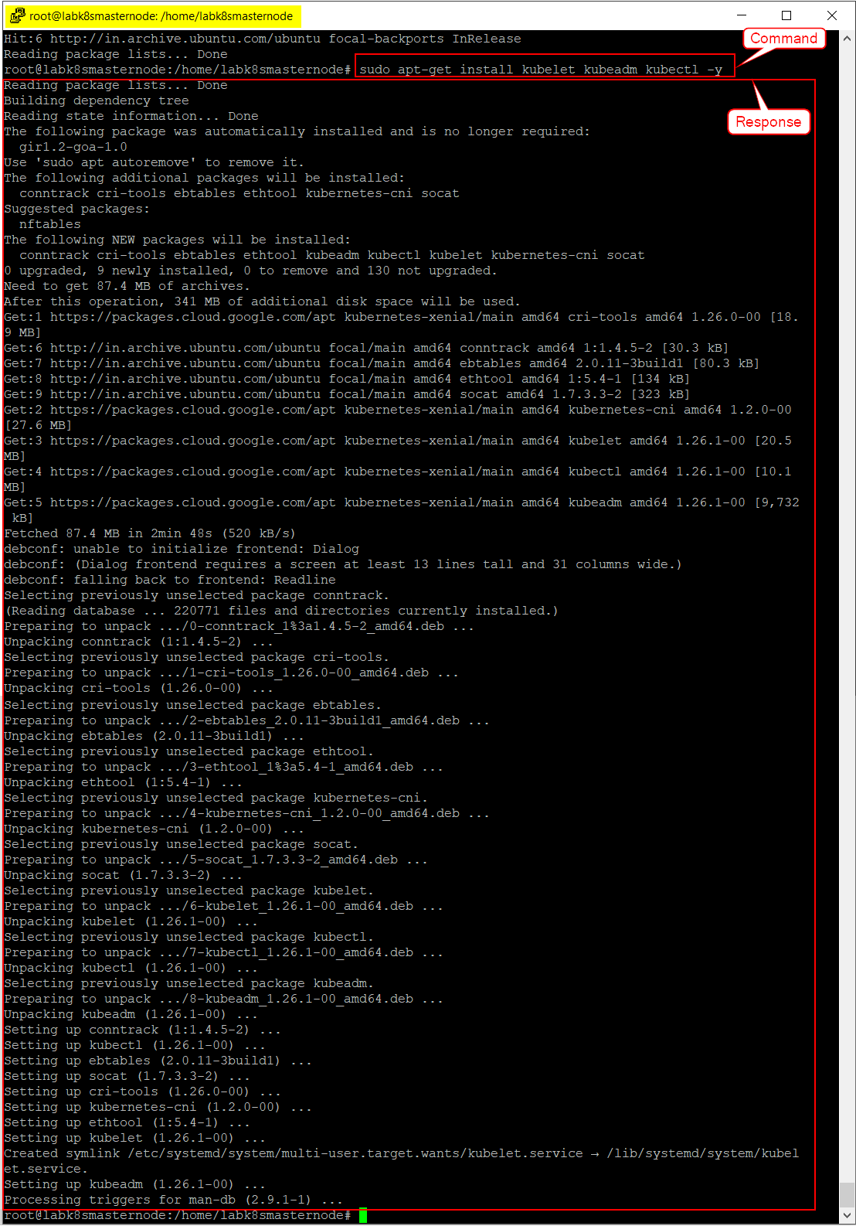

***Worker Node***

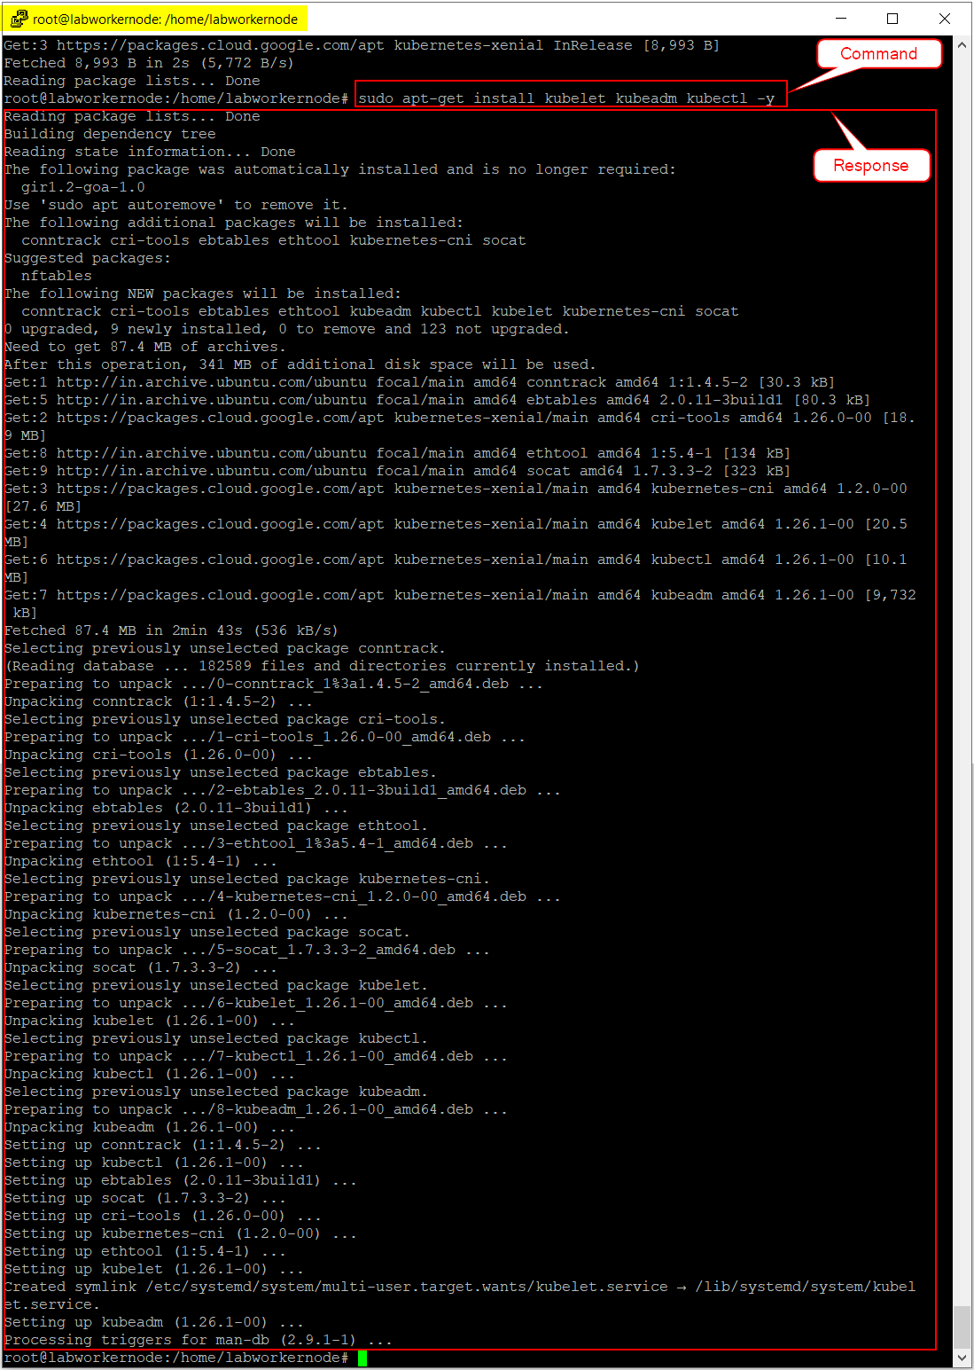

***Worker Node 1***

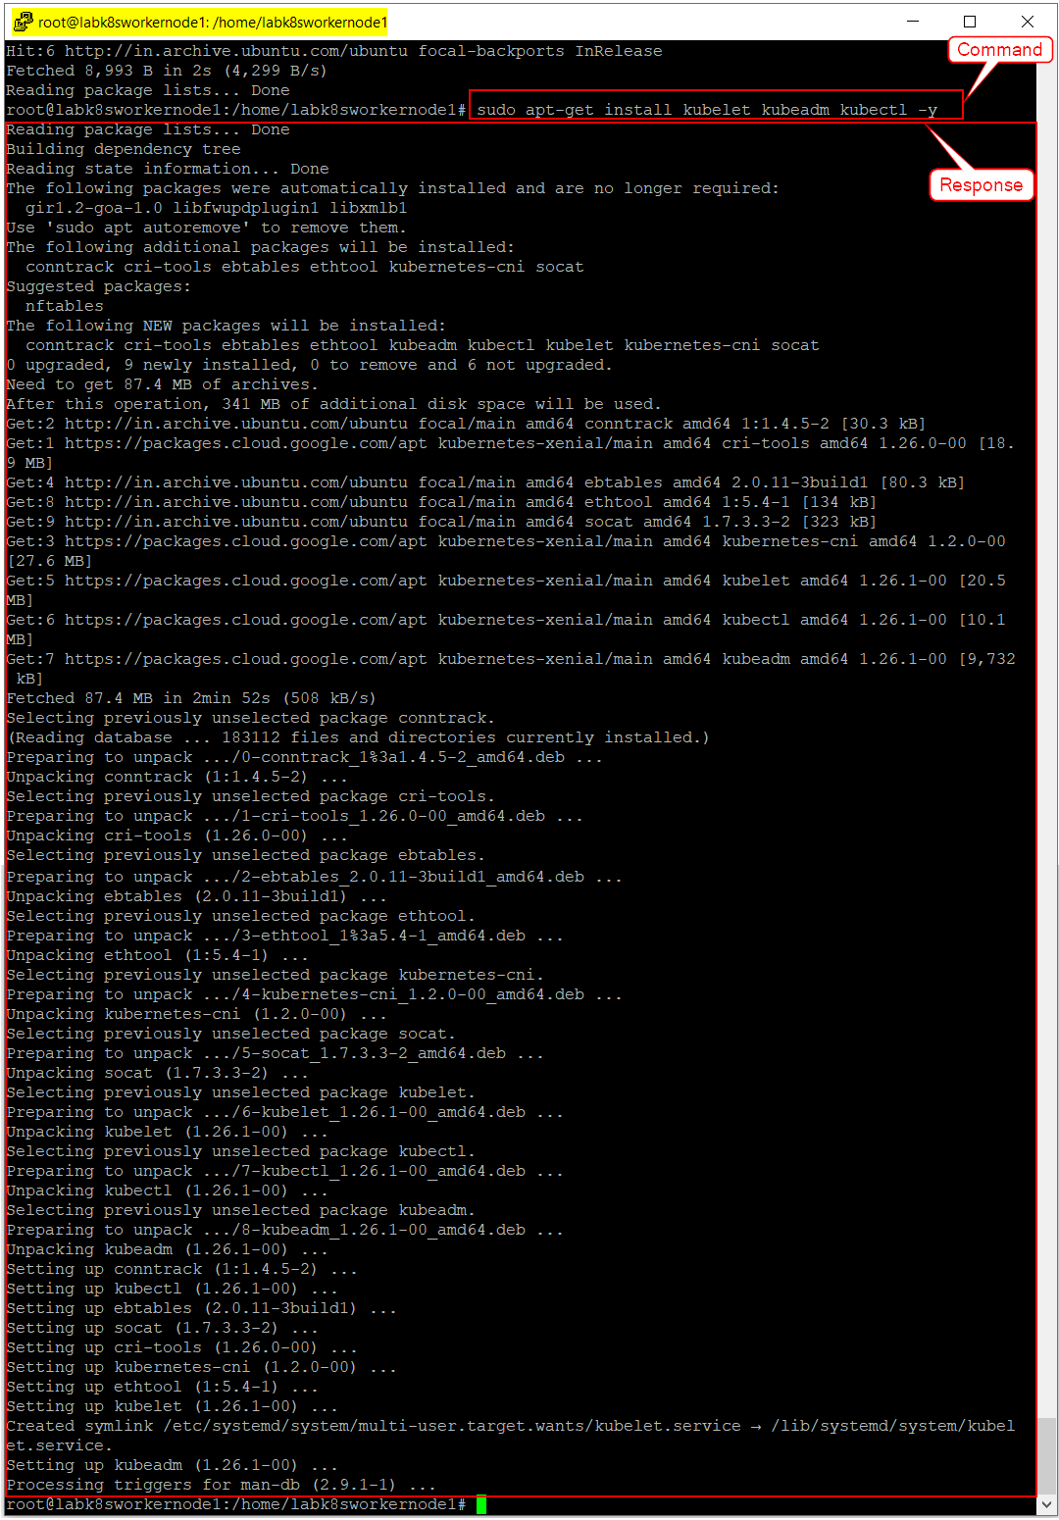

1. Run **sudo apt-mark hold kubelet kubeadm kubectl** command to freeze the Kubernetes components version installed in the previous step and prevent from being updated automatically.

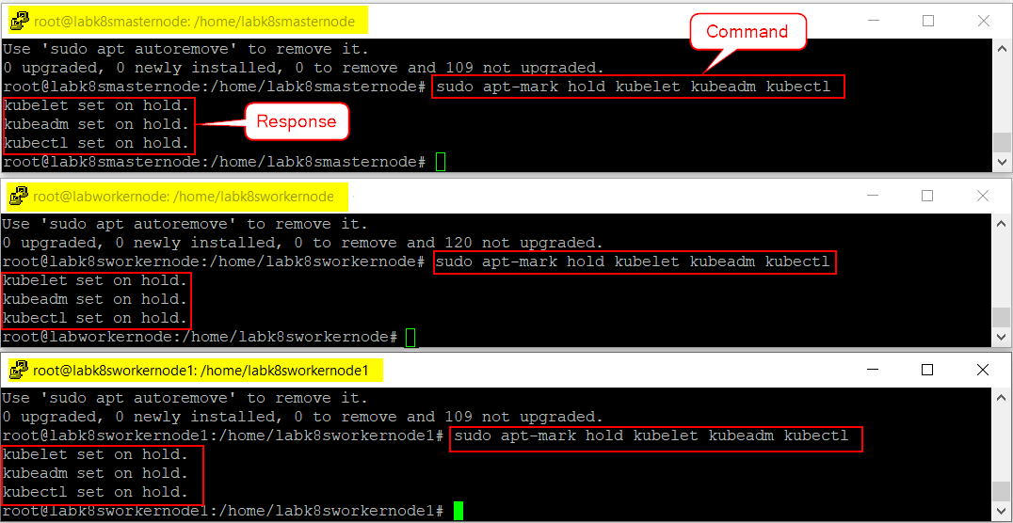

1. Once the installation is completed, it is required to update the cgroupdriver by creating a new **“daemon.json”** configuration file in **“/etc/docker”** directory.
   1. Run **cd /etc/docker** command to navigate to the docker directory.

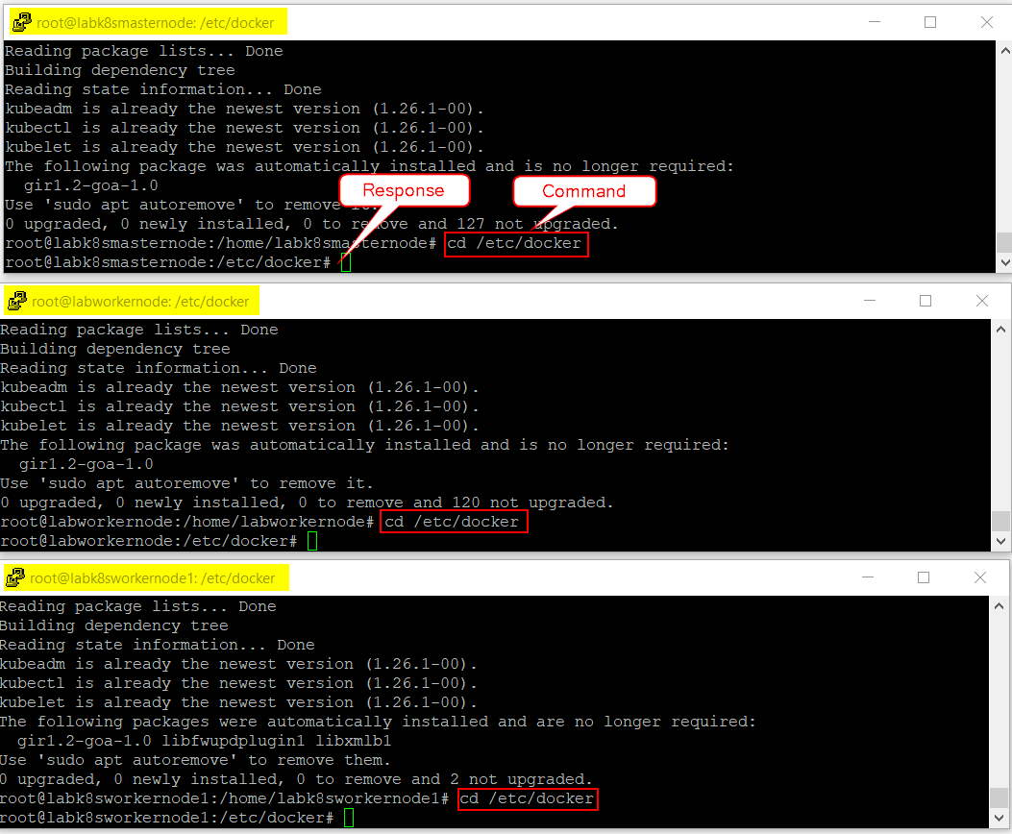

* 1. Run **sudo nano daemon.json** command to create a daemon.json configuration file.
  2. Add the below text to the json file:

**{**

**"exec-opts": ["native.cgroupdriver=systemd"]**

**}**

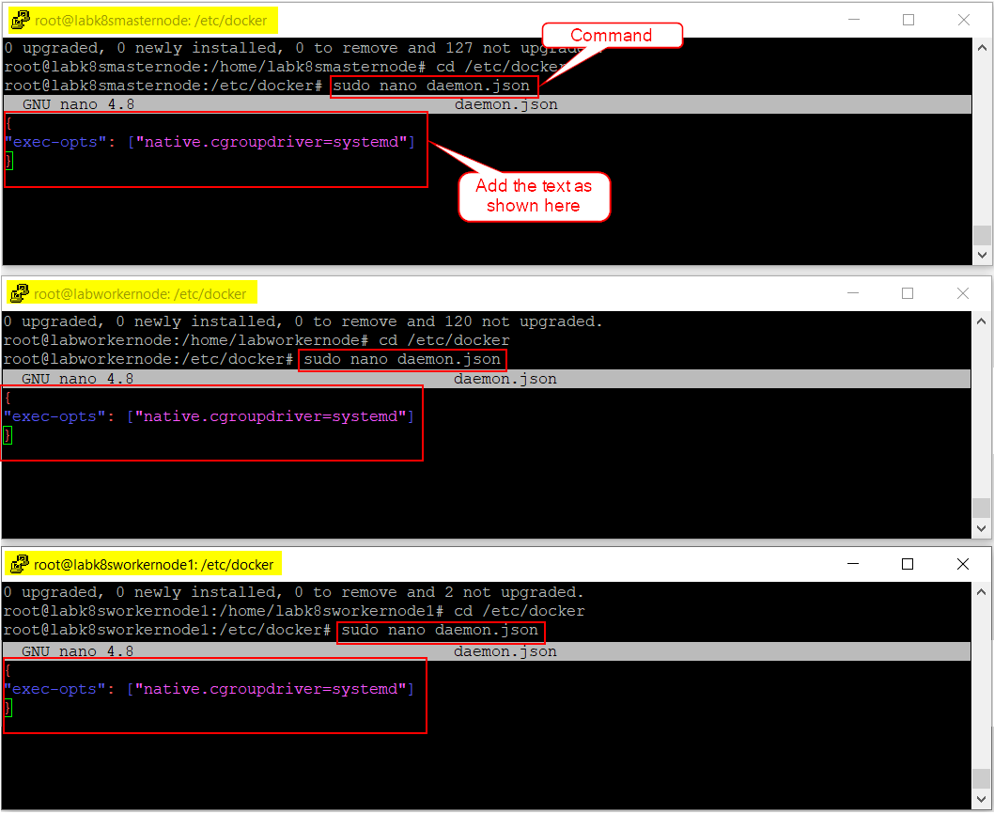

* 1. Save the daemon.json configuration file by using the following commands.
     1. Click “Cntrl + O” to Write Out the changes and then press ENTER.
     2. Click “Cntrl + X” to Exit from the file.

1. Run **sudo systemctl daemon-reload** command to reload the daemon.

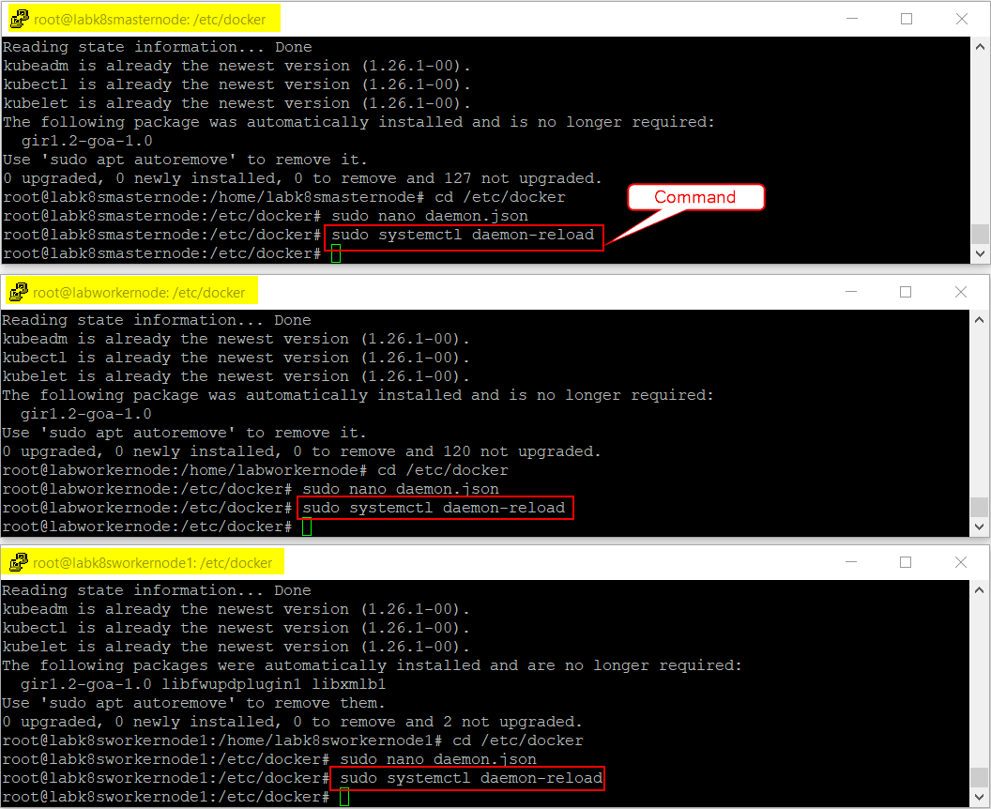

1. Run **sudo systemctl restart docker.service** command to restart the Docker service.

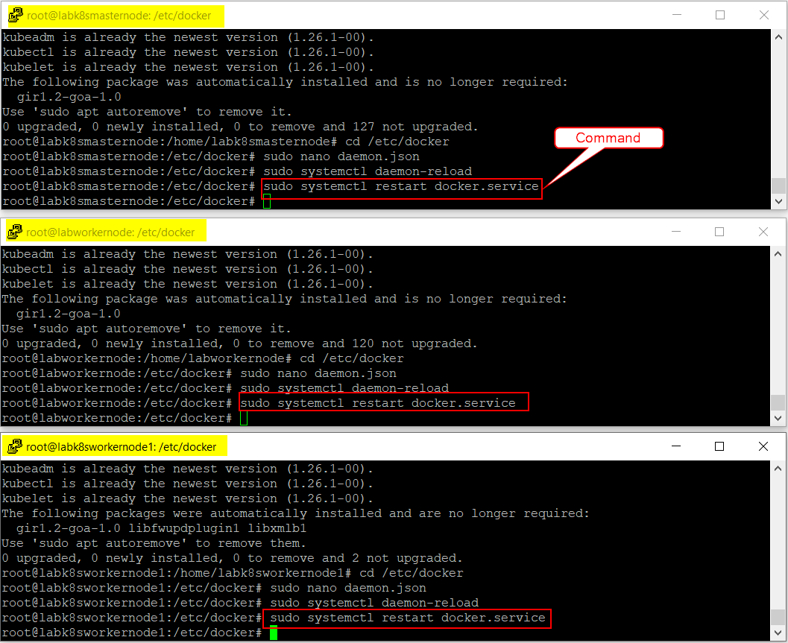

1. Verify the docker status by performing **Step 9** from **Section 2.1.5 Install Docker CE**.
2. Run **exit** command to exit from the root directory.

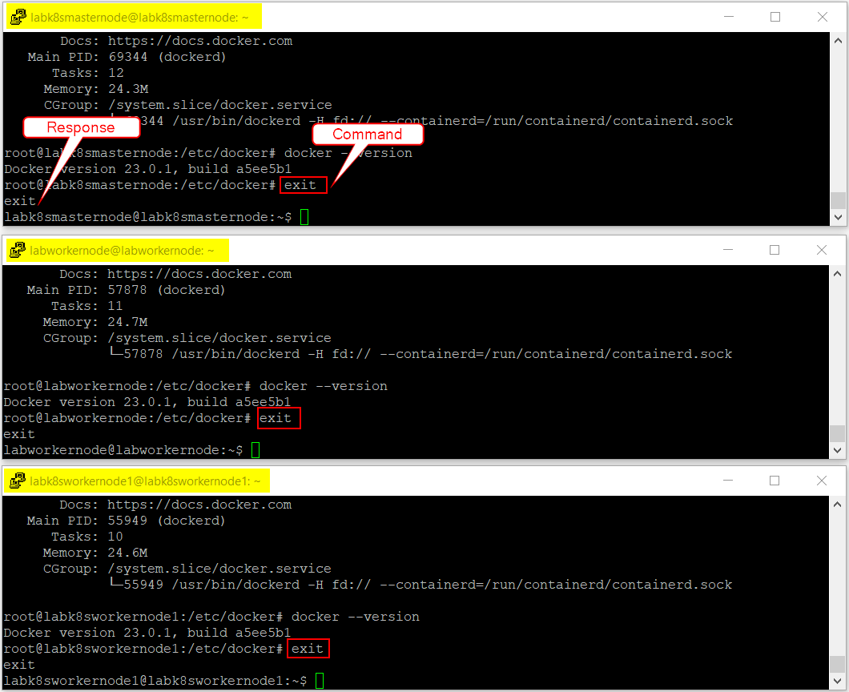

* + 1. Initialize Kubernetes in Master Node

NOTE: This process must be performed only on Master Node.

**To Initialize the Kubernetes in Master Node:**

1. Run **sudo kubeadm init --pod-network-cidr=10.244.0.0/16** command to initialize the Kubernetes cluster. If there are any errors observed during initialization, then please continue with **Step 3**.

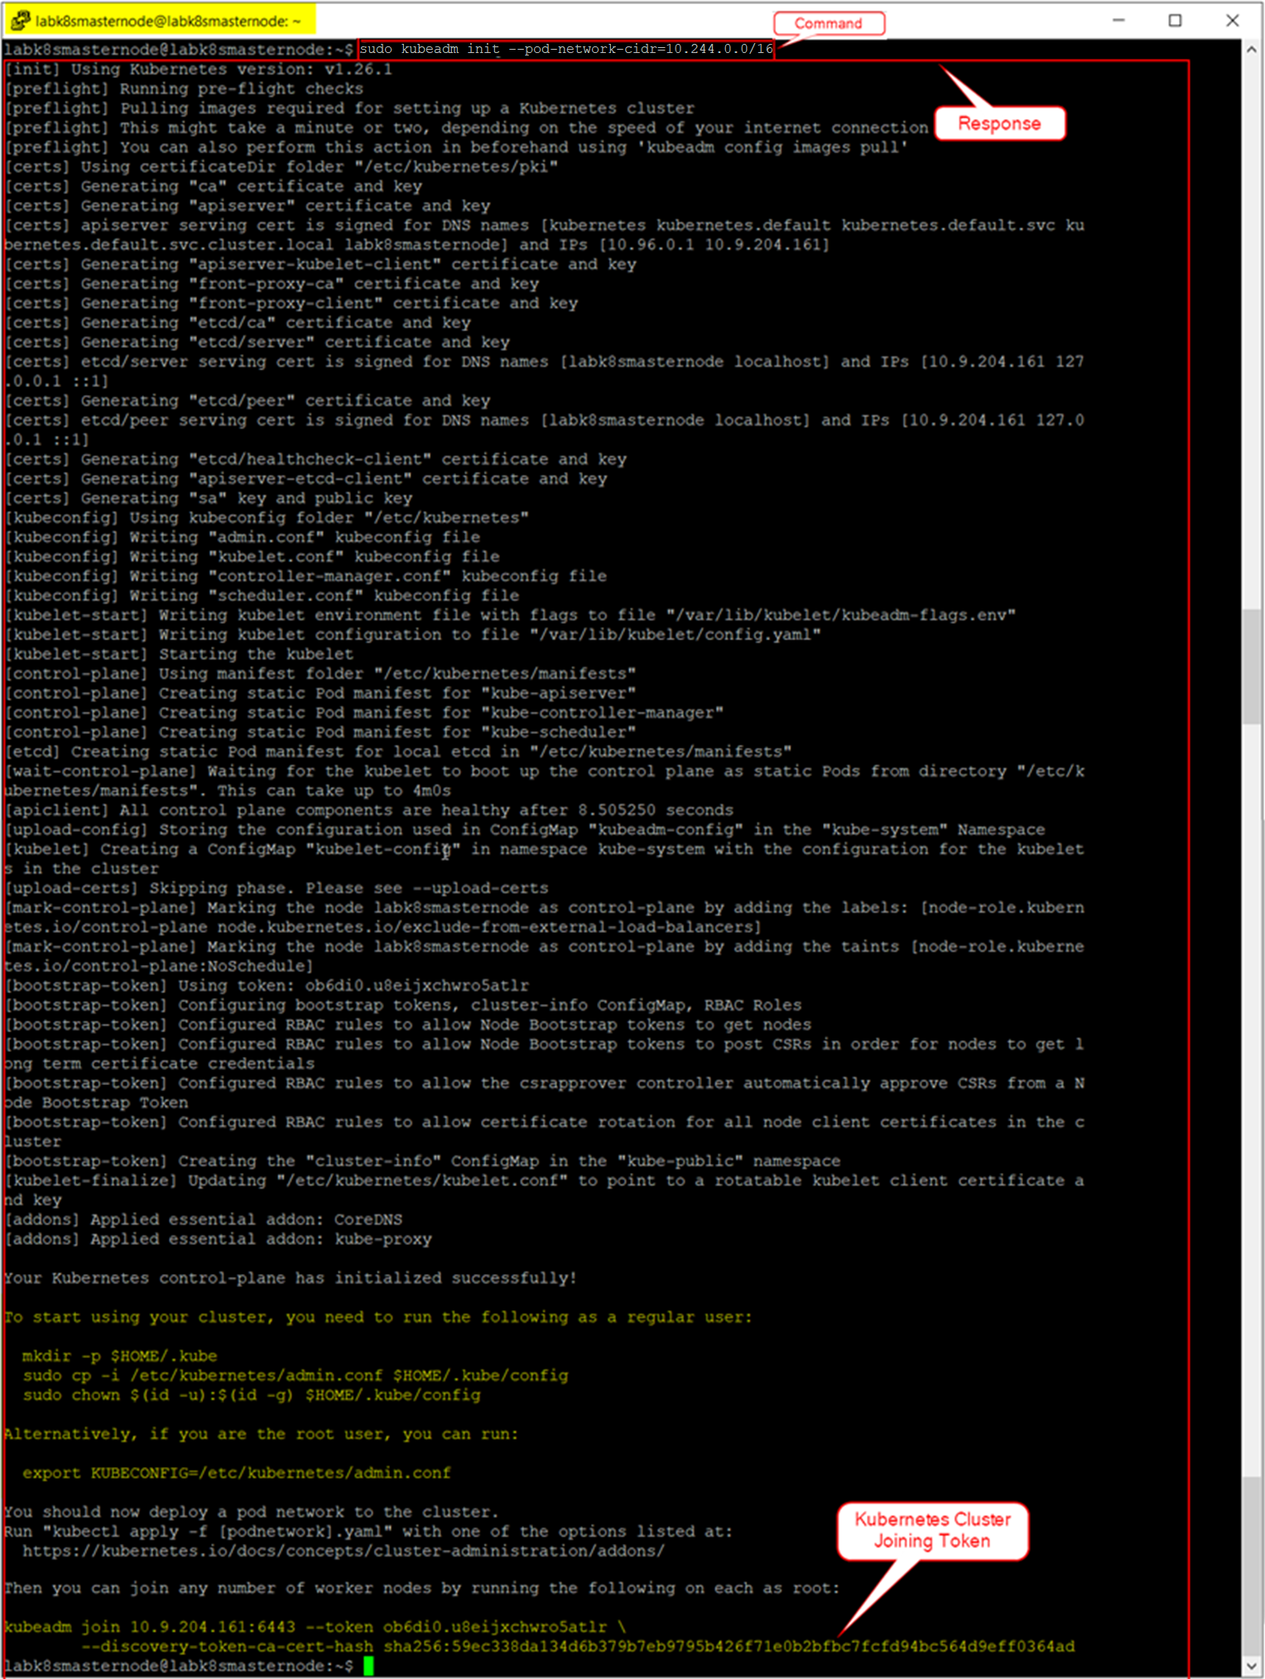

**Note:** From the above response, the ***Kubernetes Cluster Joining Token*** is a randomly generated token value and it is utilized to join the worker nodes into this cluster.

1. Run **sudo kubeadm version** command to verify the status of Kubernetes Initialization.

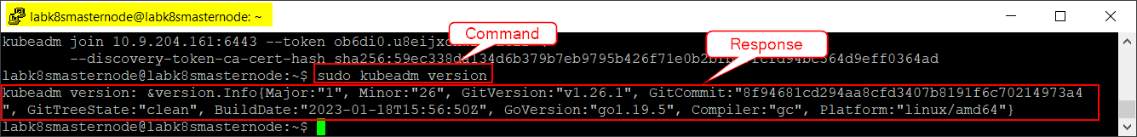

In case if there are any **Initialization Errors** occurred, then perform the below mentioned workaround steps on **all nodes**:

1. Run **sudo su** command to login to root directory.

**NOTE:** The system may ask you for the password. If you know the password, then enter the password and access the root directory. Else, contact your System Administrator. **DO NOT RUN THIS COMMAND TWICE.**

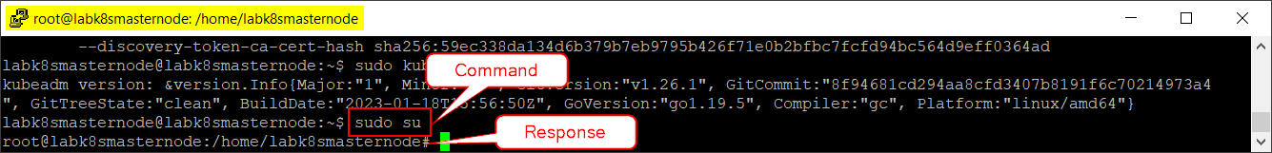

1. Run **cd /etc/containerd** command to navigate to the container directory.

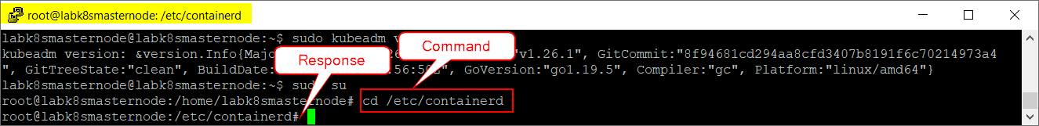

1. Run **rm config.toml** command to remove or delete the configuration file.

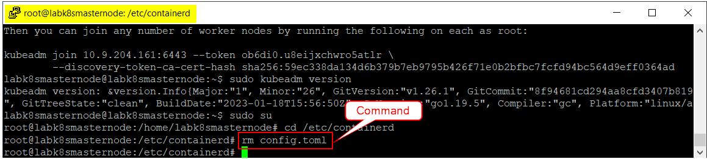

1. Run **systemctl restart containerd** command to restart the container service.

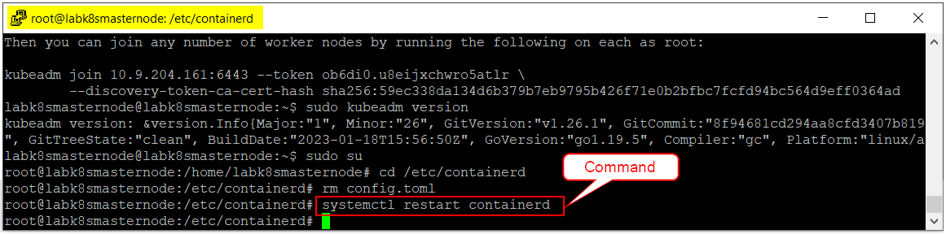

1. Run **exit** command to exit from the root directory.

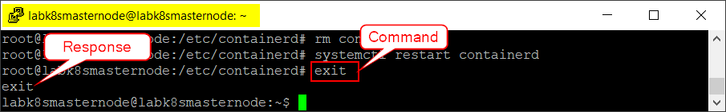

1. Once the container service is restarted, initialize the Kubernetes cluster in **Master node** by performing the above **Step 1**.

**To start using the cluster:**

1. If you are logged in as a Regular or Non-Root user, run the following commands one after the other.

* **mkdir -p $HOME/.kube**
* **sudo cp -i /etc/kubernetes/admin.conf $HOME/.kube/config**
* **sudo chown $(id -u):$(id -g) $HOME/.kube/config**

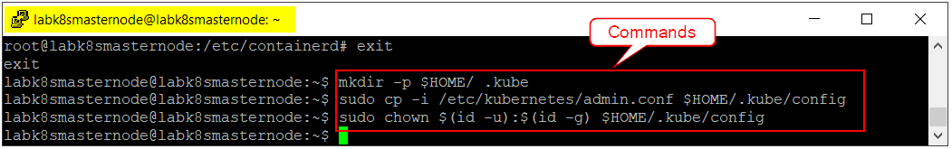

1. If you are logged in as a Root user, run the following command.

* **export KUBECONFIG=/etc/kubernetes/admin.conf**

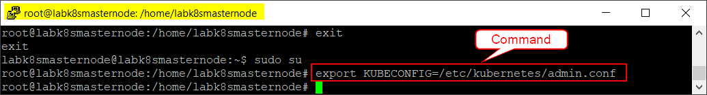

* + 1. Deploy a Pod Network

Pod Network is used for communication between all nodes within the Kubernetes cluster and is necessary for the Kubernetes cluster to function properly.

As a part of the process, a Flannel Pod Network is deployed on the Kubernetes cluster. Flannel is a virtual network that attaches IP addresses to containers.

NOTE: This process must be performed only on Master Node.

**To deploy a Pod Network:**

1. Run **kubectl apply -f** [**https://raw.githubusercontent.com/coreos/flannel/master/Documentation/kube-flannel.yml**](https://raw.githubusercontent.com/coreos/flannel/master/Documentation/kube-flannel.yml) command on Master Node to deploy a Flannel Pod Network in it.

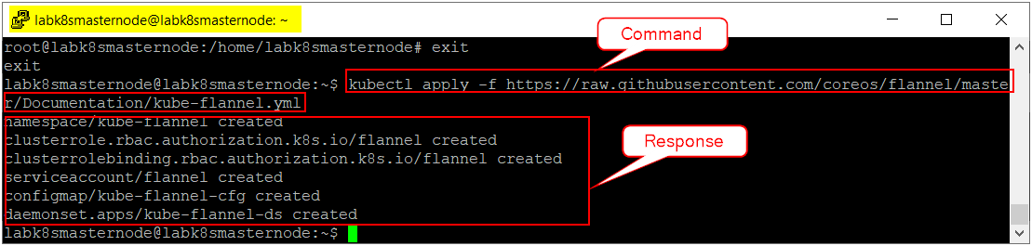

1. Run **kubectl get pods --all-namespaces** command to verify the status of all pods. If any of the pod status is displaying other than **‘Running’**, then it is recommended to wait for some time and try again with the same command.

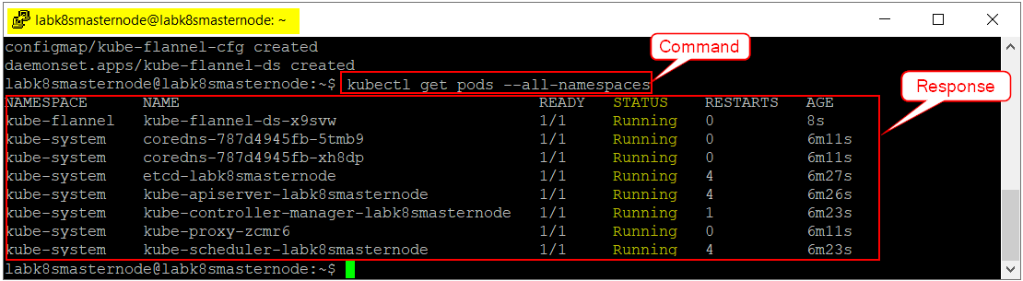

* + 1. Join Worker Nodes into Kubernetes Cluster

The worker nodes can be joined into the Kubernetes cluster once the pod network deployment is successful.

**To join the worker nodes into Kubernetes cluster:**

1. On master node, run **kubeadm token create --print-join-command** command to print the Kubernetes cluster joining command.

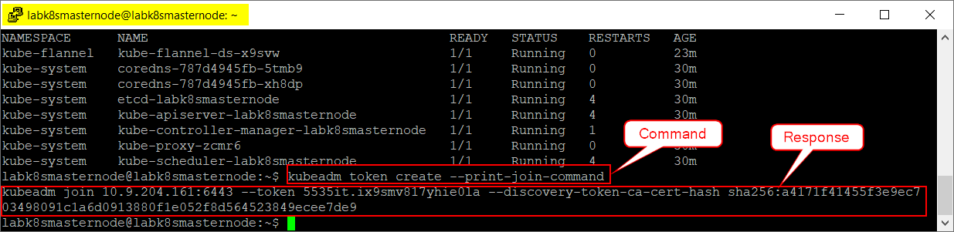

1. Copy or note down the response received from the above step and run it in both worker nodes to join them into Kubernetes cluster.

**Note:** Make sure to add **sudo** command as a prefix to Kubernetes joining cluster command.

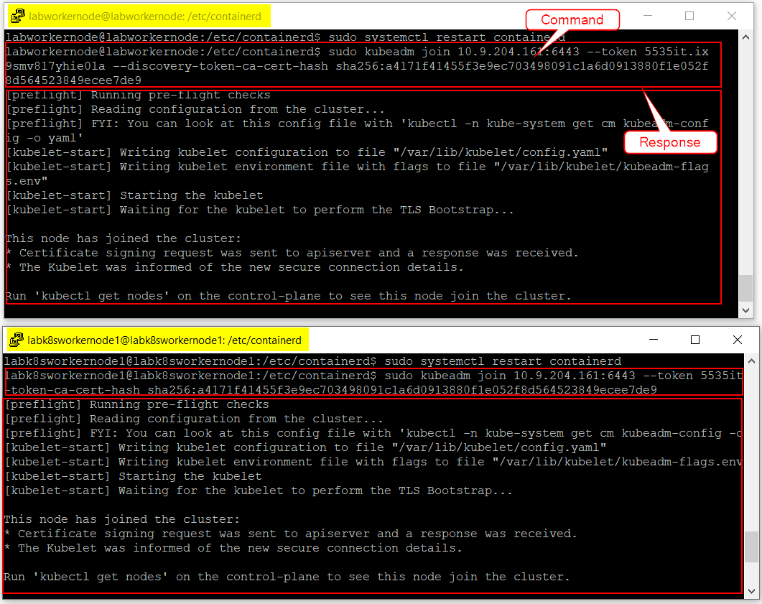

1. On master node, run **kubectl get nodes** command to verify whether both the worker nodes have joined the cluster.

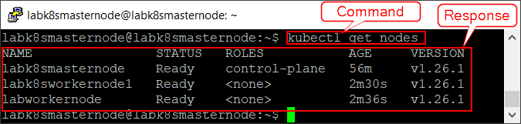

* 1. AWS CLI Installation & Setup

The AWS Command Line Interface (AWS CLI) is a unified tool to manage the AWS services like AWS ECR (to pull and push the docker images) and S3 buckets (to upload and download the objects).

NOTE: This process must be performed only on Master Node.

**To install & setup AWS CLI:**

1. Run **curl "https://awscli.amazonaws.com/awscli-exe-linux-x86_64.zip" -o "awscliv2.zip"** command to download the AWS CLI zip file.

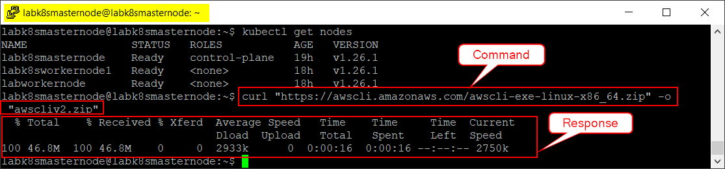

1. Run **unzip awscliv2.zip** command to unzip the installer.

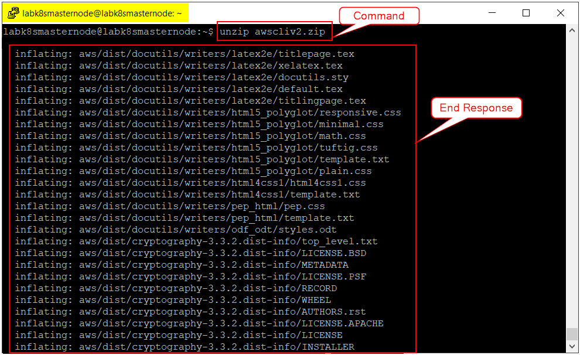

**Note:** As the response for this command is larger, we have captured only the End response in the above screenshot for reference.

1. Run **cd aws** command to go to AWS directory.

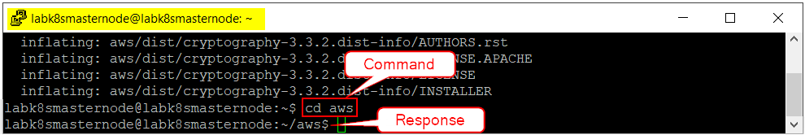

1. Run **sudo ./install -i /usr/local/aws-cli -b /usr/local/bin** command to install the AWS CLI.

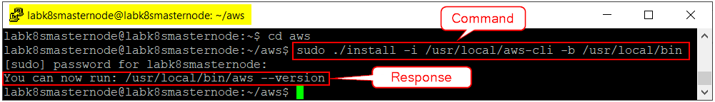

1. Run **aws --version** command to verify the installation.

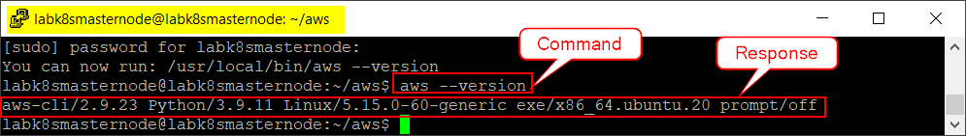

1. Run **sudo apt update** command to update the latest packages.

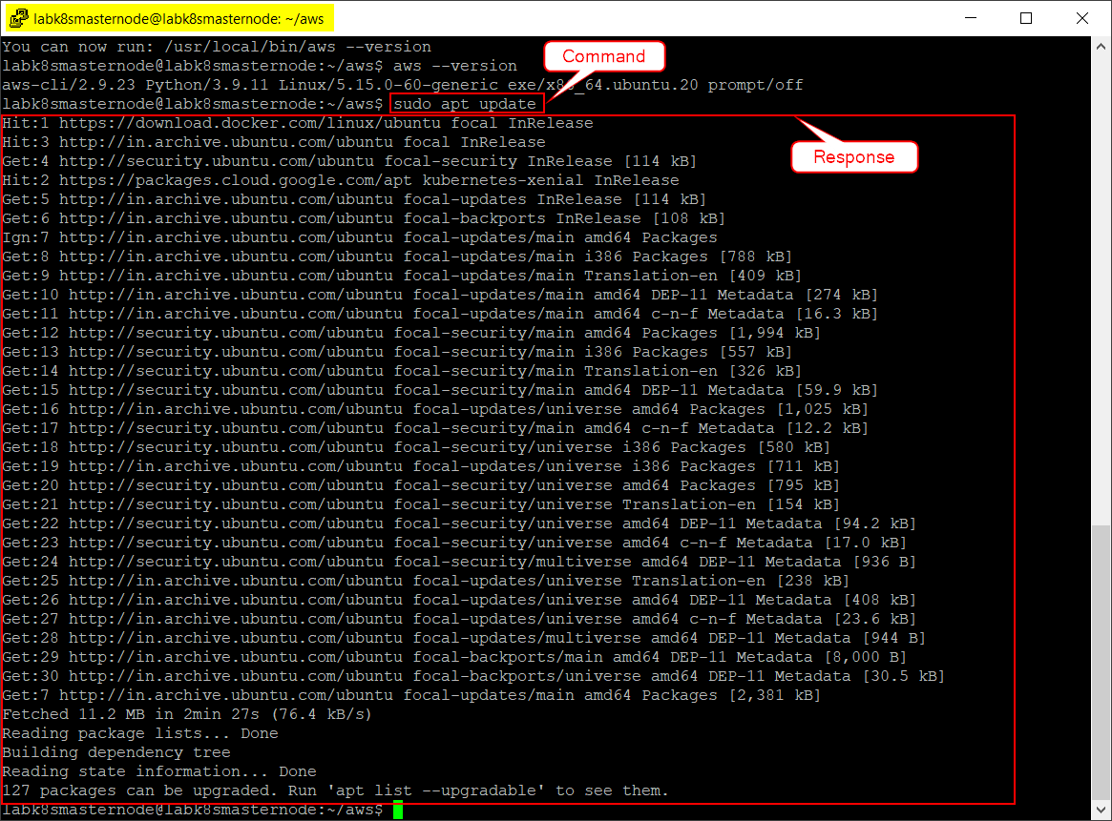

1. Run **sudo apt install amazon-ecr-credential-helper** command to install the Amazon ECR Docker Credential Helper.

**Tip:** The Amazon ECR Docker Credential Helper is a credential helper for the Docker daemon that makes it easier to use Amazon Elastic Container Registry.

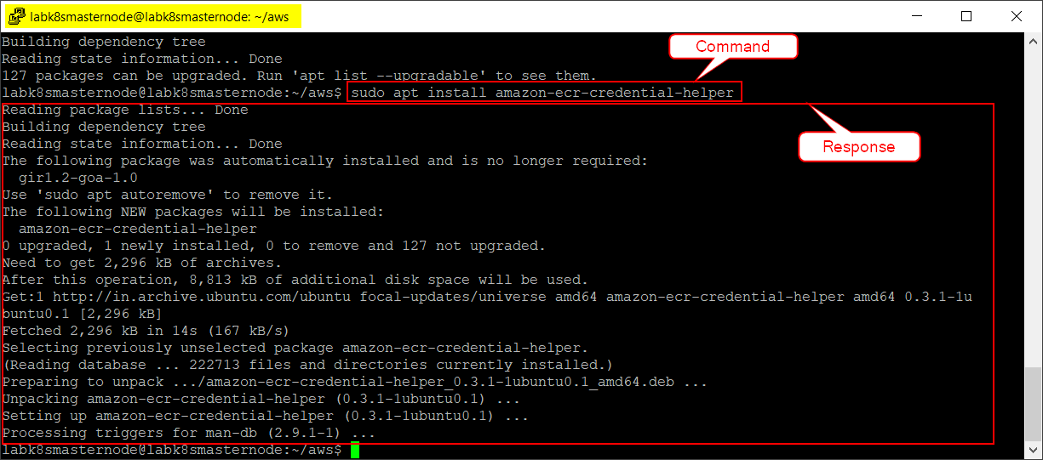

* 1. AWS Configuration

After successful installation of AWS and setting Amazon ECR Docker Credential Helper, configure AWS in the Linux server.

NOTE: This process must be performed only on Master Node.

**To configure AWS:**

1. Run **sudo su** command to login to root directory.

**NOTE:** The system may ask you for the root user password. If you know the password, then enter the password and access the root directory. Else, contact your System Administrator. **DO NOT RUN THIS COMMAND TWICE.**

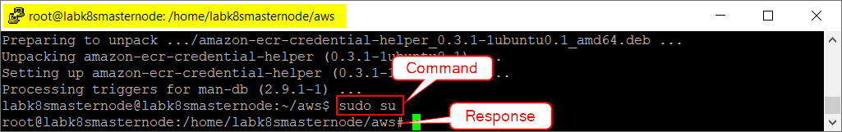

1. Run **aws configure** command to configure the AWS. Provide the following details in their respective fields:
   1. **AWS Access Key ID [None]:** Your Access Key ID
   2. **AWS Secret Access Key [None]:** Your Secret Access Key
   3. **Default region name [None]:** us-east-2
   4. **Default output format [None]:** json

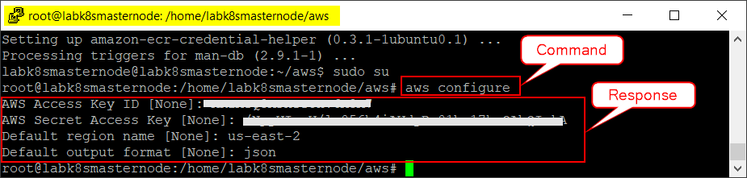

1. Run **exit** command to exit from the root directory.

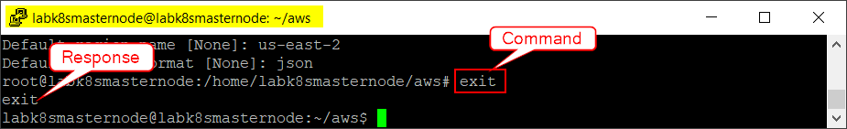

1. Repeat **Step 2** to access the AWS ECR as a non-root user.
2. Run **cd** command to come out from the AWS folder.

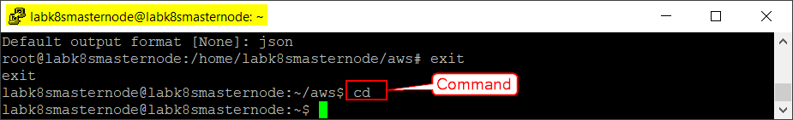

1. Run **sudo mkdir -p .docker** command to create a new docker directory.

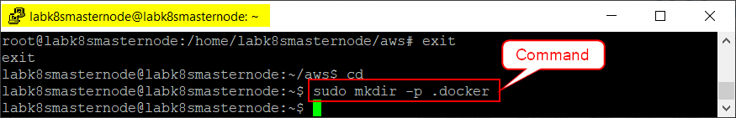

1. Run the following commands one after the other to provide the Docker directory ownership & permissions and restart the services for changes to take effect.
   * **sudo chown "$USER":"$USER" /home/"$USER"/.docker -R**
   * **sudo chmod g+rwx "$HOME/.docker" -R**
   * **sudo systemctl restart docker.service**
   * **sudo systemctl restart containerd.service**
   * **sudo systemctl daemon-reload**

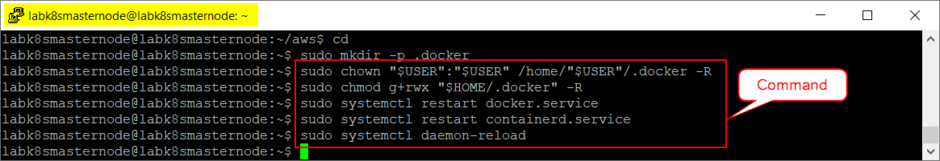

* 1. Access Docker with AWS ECR

NOTE: This process must be performed only on Master Node.

1. Run **sudo su** command to login to root directory.

**NOTE:** The system may ask you for the password. If you know the password, then enter the password and access the root directory. Else, contact your System Administrator. **DO NOT RUN THIS COMMAND TWICE.**

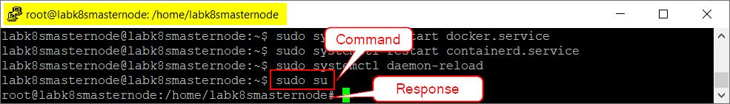

1. Run **aws ecr get-login-password --region us-east-2 | docker login --username AWS --password-stdin 585953033457.dkr.ecr.us-east-2.amazonaws.com** command to login to AWS ECR repository to pull and push the Docker images.

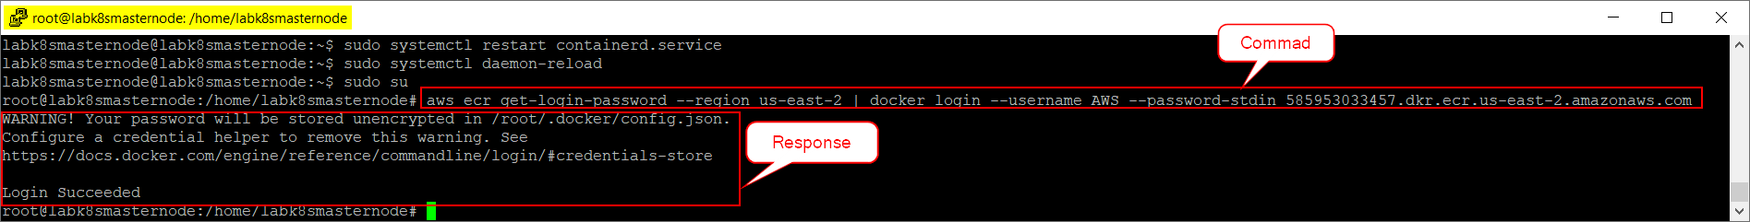

1. Run **exit** command to exit from the root directory.

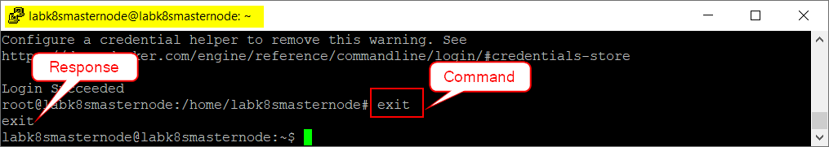

1. Repeat **Step 2** to login to AWS ECR repository as a non-root user.

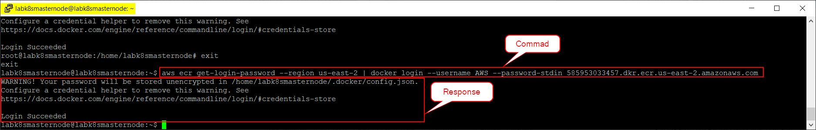

* 1. NFS Server and Client Setup

NFS Server is used as a third-party storage server. This NFS Server must be setup on a Virtual Machine and contain a specific Username and Password to login to it. Once the VM is ready, follow the instructions provided in **Section 2.1.2** to connect with the VM.

**Note:** Following is the sample VM used to setup NFS Server in this document. Make sure to replace it accordingly with your NFS Server IP address wherever it is applicable.

|  |  |  |
| --- | --- | --- |
| Username | VMs IP Address | Operating System |
| nfsserver | 10.9.204.133 | Ubuntu 20.04 |

**To install NFS Server on Ubuntu 20.04 LTS:**

1. Run **sudo apt update** command to update latest packages.

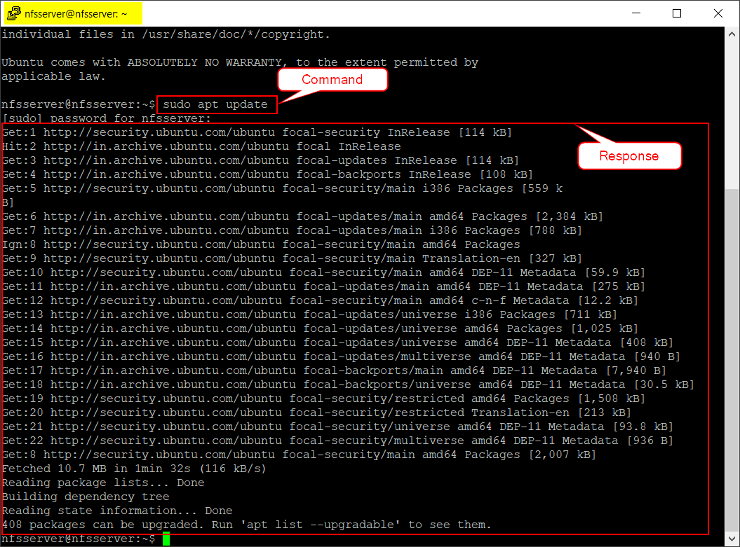

1. Run **sudo apt install nfs-kernel-server -y** command to install NFS Server.

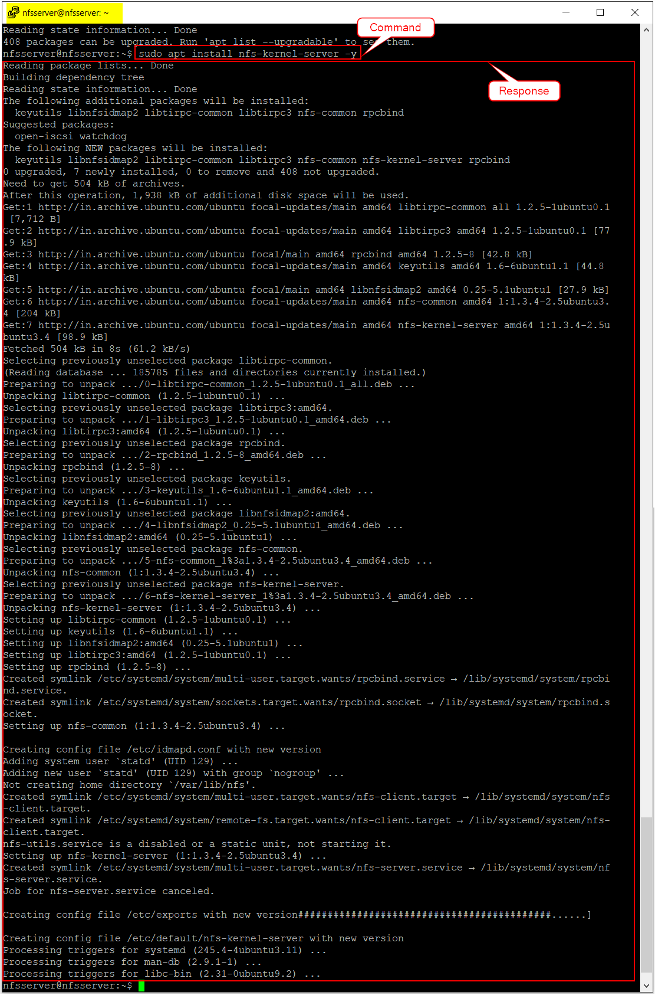

**To configure NFS Server on Ubuntu 20.04 LTS:**

1. Run **sudo mkdir -p /mnt/nfs-share** command to create a NFS Shared directory.

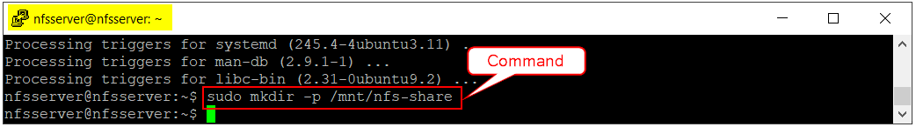

1. Run **sudo chown -R nobody:nogroup /mnt/nfs-share** command to set the directory permissions.

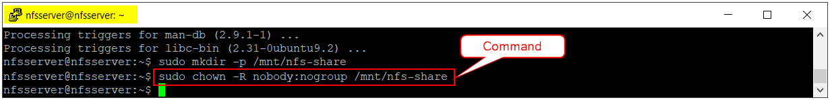

1. Run **cd** **/mnt/nfs-share** to navigate to the nfs-share folder.

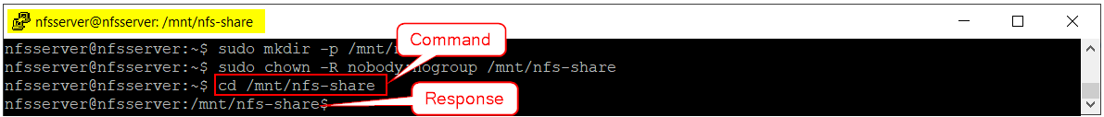

1. Run **sudo mkdir -p data rabbitmq redis-data Output elk** to create directories for PostgreSQL, RabbitMQ, Redis Server, Output, and ElasticSearch to store their respective data.

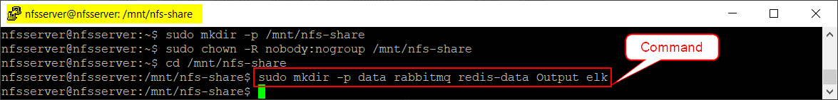

1. Run **sudo chmod -R 777 /mnt/nfs-share/elk** command to provide file permissions.

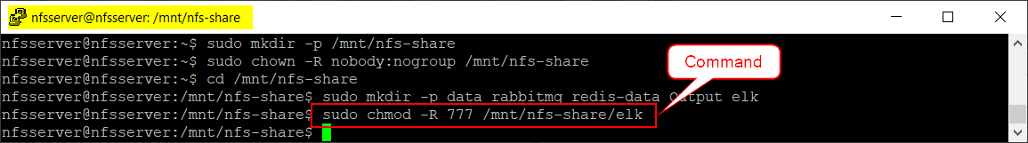

1. To grant access to NFS:
   1. Run **sudo nano /etc/exports** command to open exports file.
   2. Add the below text to the exports file:

**/mnt/nfs-share *(rw,sync,no_subtree_check,no_root_squash,no_all_squash,insecure)**

**Note:** In the above text, **asterisk (*)** symbol is used to provide access to the NFS Shared directory for all the systems. If you want to provide access to the NFS Shared directory only for a specific system, then replace the asterisk symbol with the IP Address of the system.

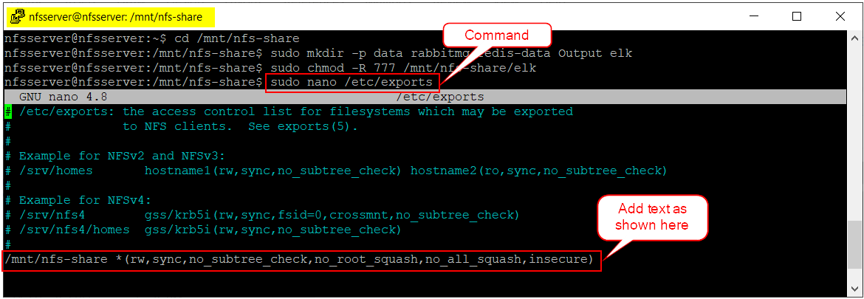

* 1. Save the exports file by using the following commands.
     1. Click “Cntrl + O” to Write Out the changes and then press ENTER.
     2. Click “Cntrl + X” to Exit from the file.

1. Run **sudo exportfs -a** command to export the NFS directory.

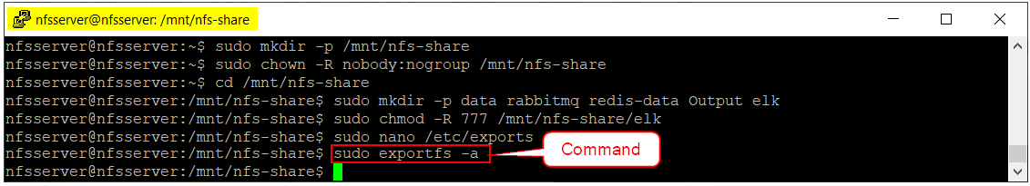

1. Run **sudo systemctl restart nfs-kernel-server** command to restart the NFS Server.

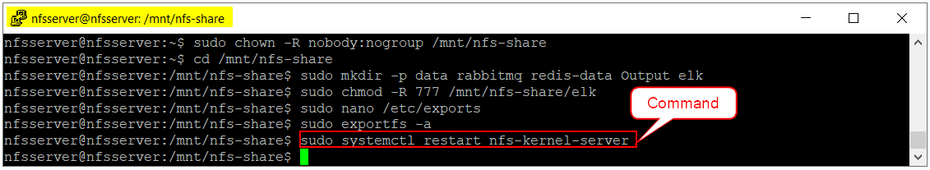

* + 1. NFS Client Setup

NFS Client must be setup on all three Kubernetes Cluster nodes (Master and Worker). Make sure to connect back to the Kubernetes Cluster nodes by following the instructions provided in **Section 2.1.2**.

**Note:** The screenshots provided in this section are taken from Master Node only. Ensure that the same process is repeated in both worker nodes as well.

**To setup NFS Client:**

1. Run **sudo apt install nfs-common** command to install NFS Client.

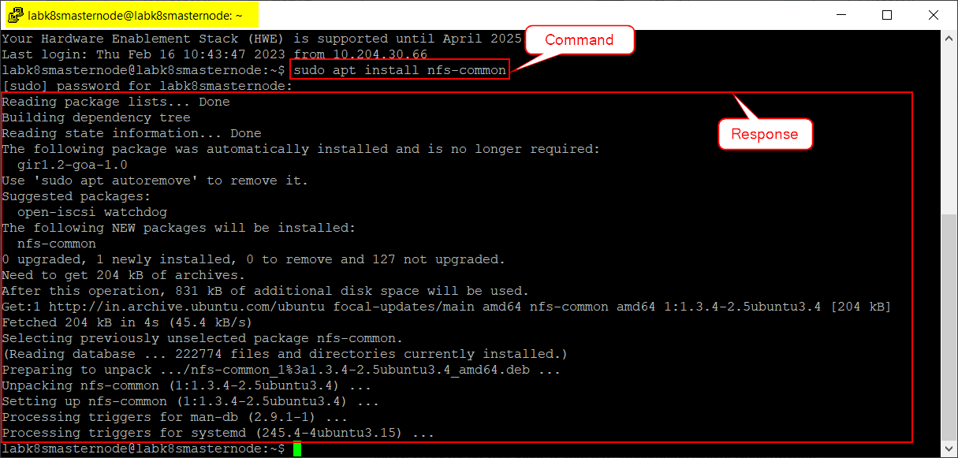

1. Once the installation is completed, run the following commands one after the other to mount the NFS Server on your VMs *(i.e., all Kubernetes Cluster Nodes)*.
   * **sudo mkdir -p /mnt/nfs_clientshare**
   * **sudo mount 10.9.204.133:/mnt/nfs-share /mnt/nfs_clientshare**

**Note:** In the above command, **10.9.204.133** is the IP address of the system where the NFS Server is installed. Make sure to change it accordingly with your NFS Server System’s IP address before running the command.

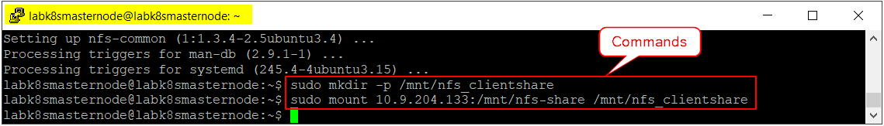

* 1. Deploy CertScan Application
     1. Preliminary Actions

Following are the preliminary actions that are to be performed before deploying the CertScan application.

1. Open CERTSCAN® software release package provided to you.
2. Go to “BuildScripts à certscan-kubernetes-kustomize 🡪 backend-services 🡪 nfs” folder.
3. Open “**kustomization.yaml**” file in notepad.

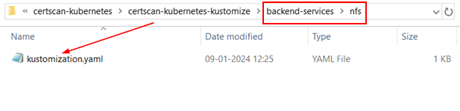

1. Change the “NFS_SERVER_IP” value with your NFS Server System’s IP Address. For example, **10.9.204.133** is the NFS Server IP address used as per this document.

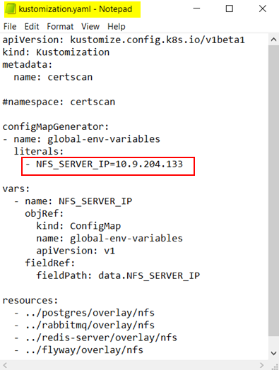

1. Save and close the file.
2. Go to “BuildScripts à certscan-kubernetes-kustomize à frontend-services 🡪 nfs” folder and repeat the actions mentioned in above **Step 3, Step 4 and Step 5**.

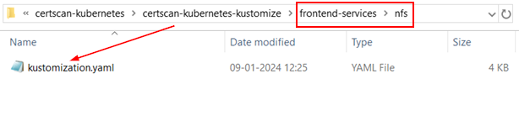

1. Go to “BuildScripts à certscan-kubernetes-kustomize à logaggregation” folder and repeat the actions mentioned in above **Step 3, Step 4 and Step 5**.

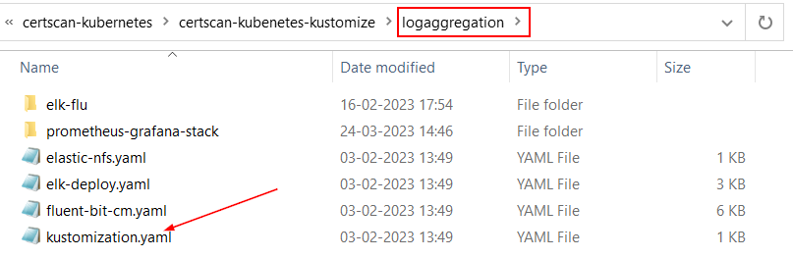

1. Go to “BuildScripts à certscan-kubernetes-kustomize à haproxy-ingress” folder.
2. Open “**haproxy-ingress-controller.yaml**” file in notepad.

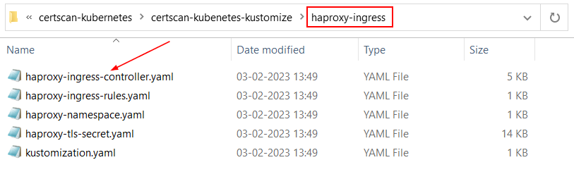

1. Scroll to the very bottom of the file and change the “externalIPs” values with the IP addresses of all 3-node Kubernetes Cluster. For example, **10.9.204.161 (master node), 10.9.204.159 (worker node) and 10.9.204.53 (worker node 1)** are the IP addresses used to setup 3-node Kubernetes Cluster as per this document.

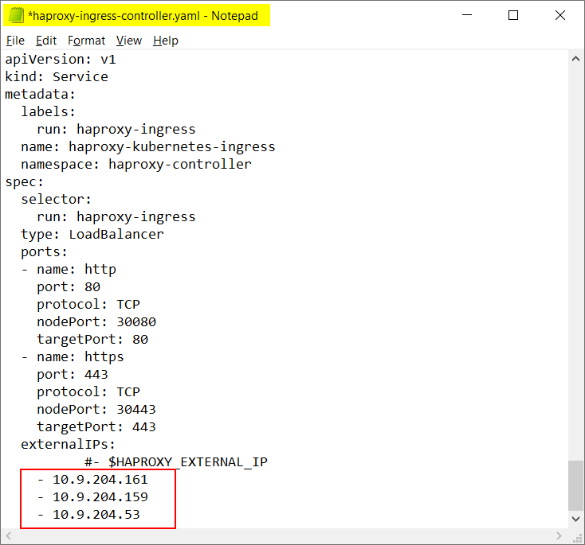

1. Save and close the file.
2. By using, WinSCP application, copy “**certscan-kubernetes-kustomize**”, **“certscan.pem”** folders and **Aws-EcrReg-Authentication.sh** file from release package and paste them into the Kubernetes Master Node VM’s $HOME directory. For example, **10.9.204.161** is the Kubernetes Master Node IP address as per this document.
   * 1. Deployment of CertScan application

This deployment process must be performed only in **Master Node**. Follow the below steps to deploy the CertScan application.

1. Run **sudo chmod -R 777 $HOME/certscan-kubernetes-kustomize** command to provide permissions to the certscam-kubernetes-kustomize directory.



1. Run **sudo chmod +x Aws-EcrReg-Authentication.sh** command to provide execution permissions to the shell script.



1. Run **./Aws-EcrReg-Authentication.sh** command to execute the shell script.

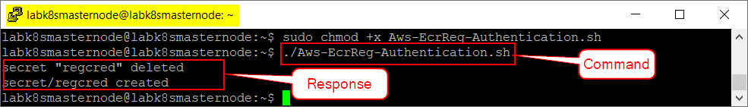

**Note:** This authentication token will get expired after every 12 hours from the time it is created. So, follow the instructions provided in **CronJob Setup** to automate the creation of new authentication token by executing “./Aws-EcrReg-Authentication.sh” command through CronJob.

1. Run **cd** **~/certscan-kubernetes-kustomize/backend-services/nfs** command to navigate to the backend-services 🡪 nfs folder.

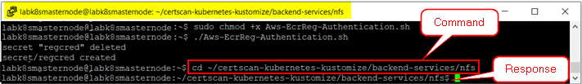

1. Run **kubectl apply -k .** command to execute the backend services that are required to deploy CertScan application.  
   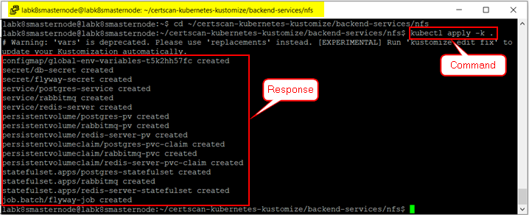
2. Run **cd** **~/certscan-kubernetes-kustomize/frontend-services/nfs** command to navigate to the frontend-services 🡪 nfs folder.  
   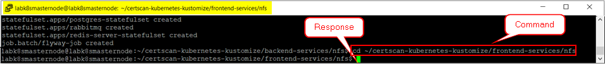
3. Run **kubectl apply -k .** command to execute the frontend services that are required to deploy CertScan application.

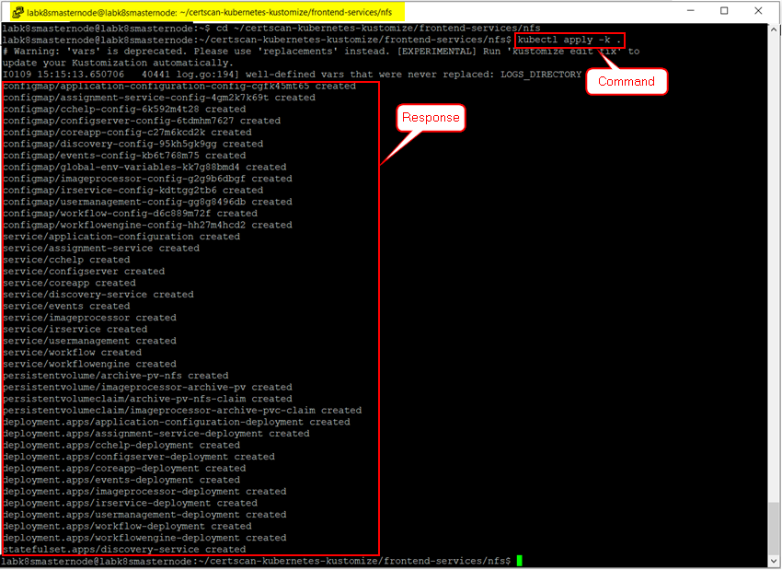

1. Run **cd ~/certscan-kubernetes-kustomize/haproxy-ingress** command to navigate to the haproxy-ingress folder.

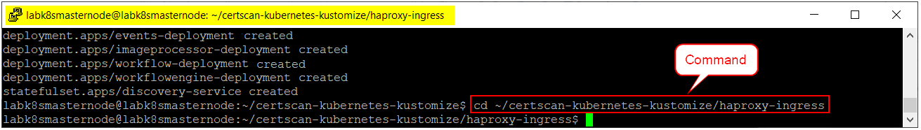

1. Run **kubectl apply -k .** command to execute the haproxy-ingress related services.

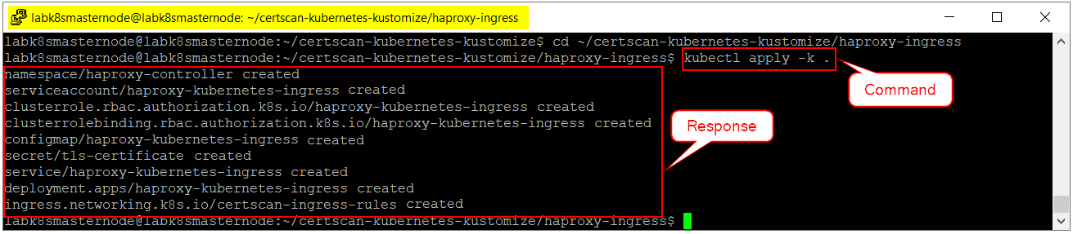

1. Run **cd ~/certscan-kubernetes-kustomize/logaggregation** command to navigate to the logaggregation folder.  
   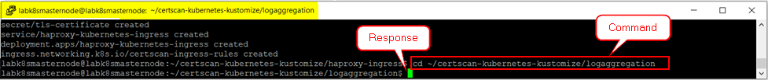
2. Run **kubectl apply -k .** command to execute the logaggregation related services.  
   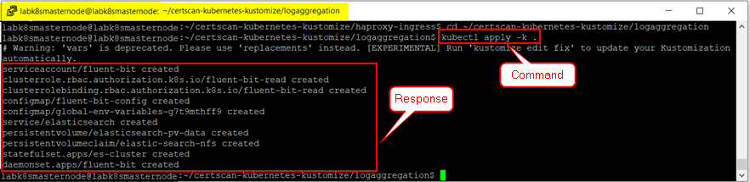
3. Run **cd** to navigate to $HOME directory.

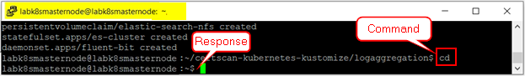

1. Run **kubectl get pods** to verify the status of all CertScan services.

**Notes:**

Except flyway service, if any of the service status is displaying other than **‘Running’**, then it is recommended to wait for some time (at least for 30 minutes) and try again with the same command.

The status of the flyway service should be displayed as **‘Completed’**.

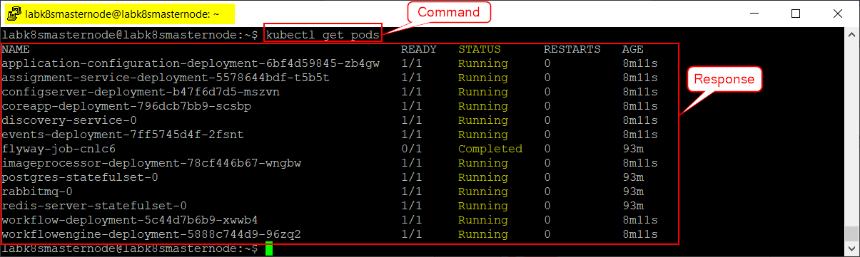

1. Go to “**C:\Windows\System32\drivers\etc**” folder in your local windows system.
2. Open “hosts” file in notepad as an administrator.

**Note:** Please contact your System Administrator if you are unable to open this file in admin mode.

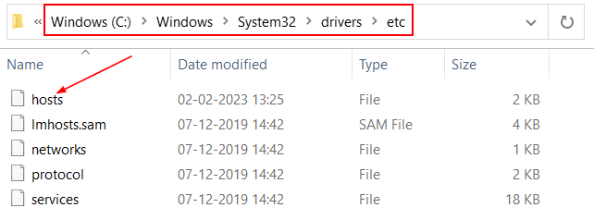

1. At the very bottom of the file, add Master Node System’s IP Address along with the URL text (**portal.certscan.net**) as shown below.

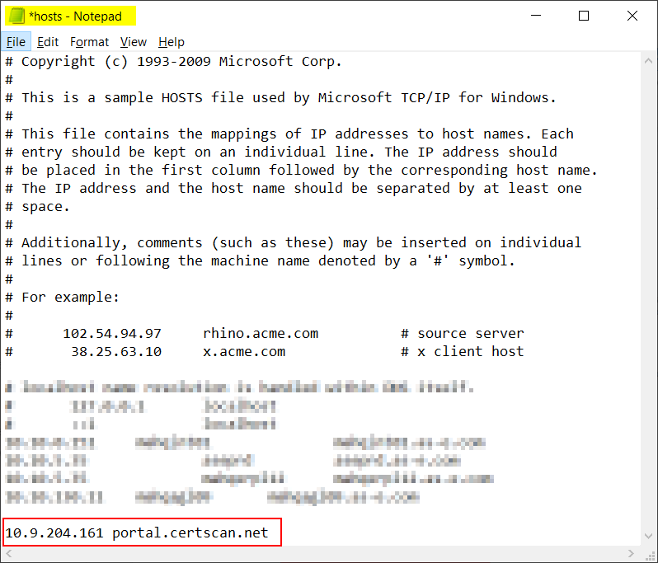

1. Save and close the file.
   * 1. CronJob Setup

Cron Jobs are scheduled to automate the execution of repetitive tasks (i.e., commands or scripts) at a specified time internal. This process must be performed only on **Master Node**.

1. Run **crontab -e** command to create a CronJob and include the tasks to be run by cron.

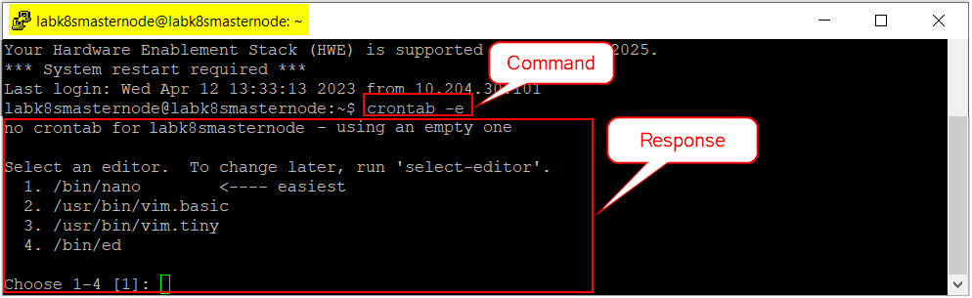

1. Type **1** and then press Enter from the keyboard to select **nano** as an editor.
2. Add the below text at the end of the CronJob:

**0 */12 * * * /home/labk8smasternode/Aws-EcrReg-Authentication.sh >> /home/labk8smasternode/aws-ecr-update-credentials.log 2>&1**

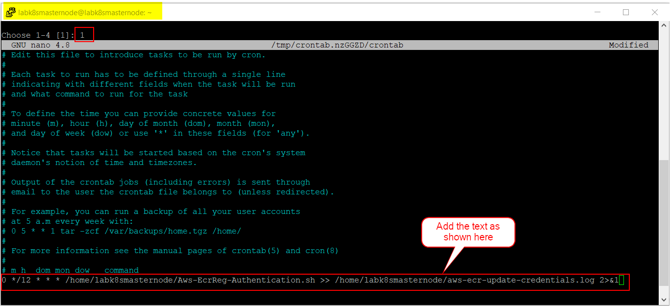

**Note:** In the above text, **/12** is the time period in hours to run the task automatically without any manual intervention. It is a configurable value and can be modified as per your requirement.

1. Save the CornJob by using the following commands.
   1. Click “Cntrl + O” to Write Out the changes and then press ENTER.
   2. Click “Cntrl + X” to Exit from the file.
      1. Access CertScan Application
2. Open Google Chrome browser.
3. Type “<https://portal.certscan.net/csview>” URL to access CertScan application.

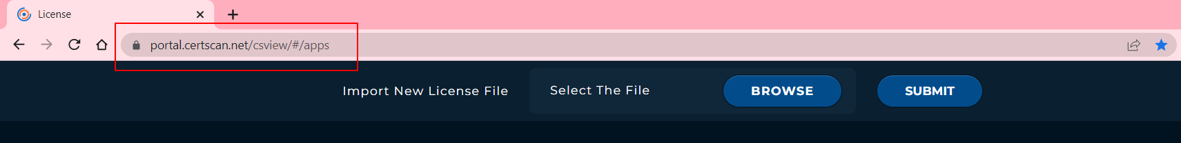

1. Click on **Browse** button and upload the license file that is generated by CertScan License Management Tool. Please contact S2 Support Team if there is no license file available.
2. Once the file is uploaded, click on **Submit** button to import the license file.

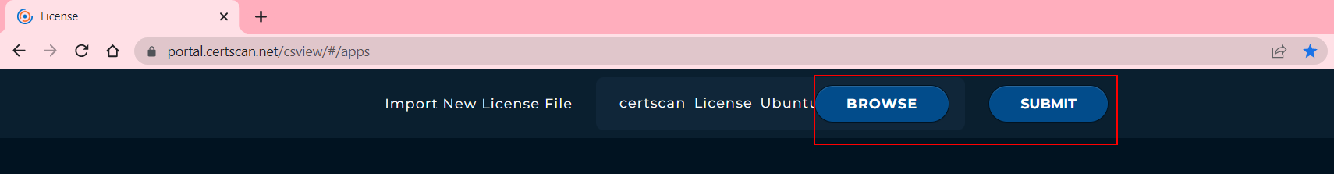

1. Verify the license details and select the checkbox to agree the terms and conditions and then click on **SAVE** button.

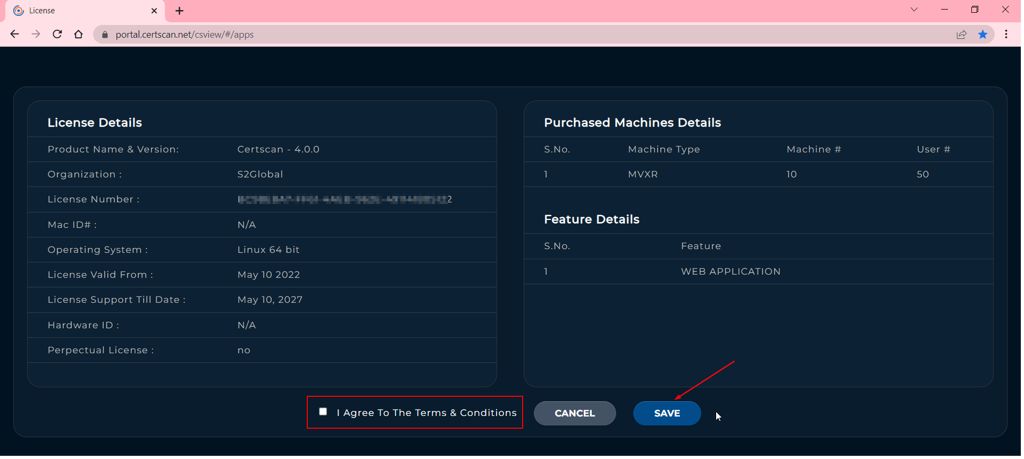

1. Enter your User ID and Password associated with CertScan application and click on **Login** button.

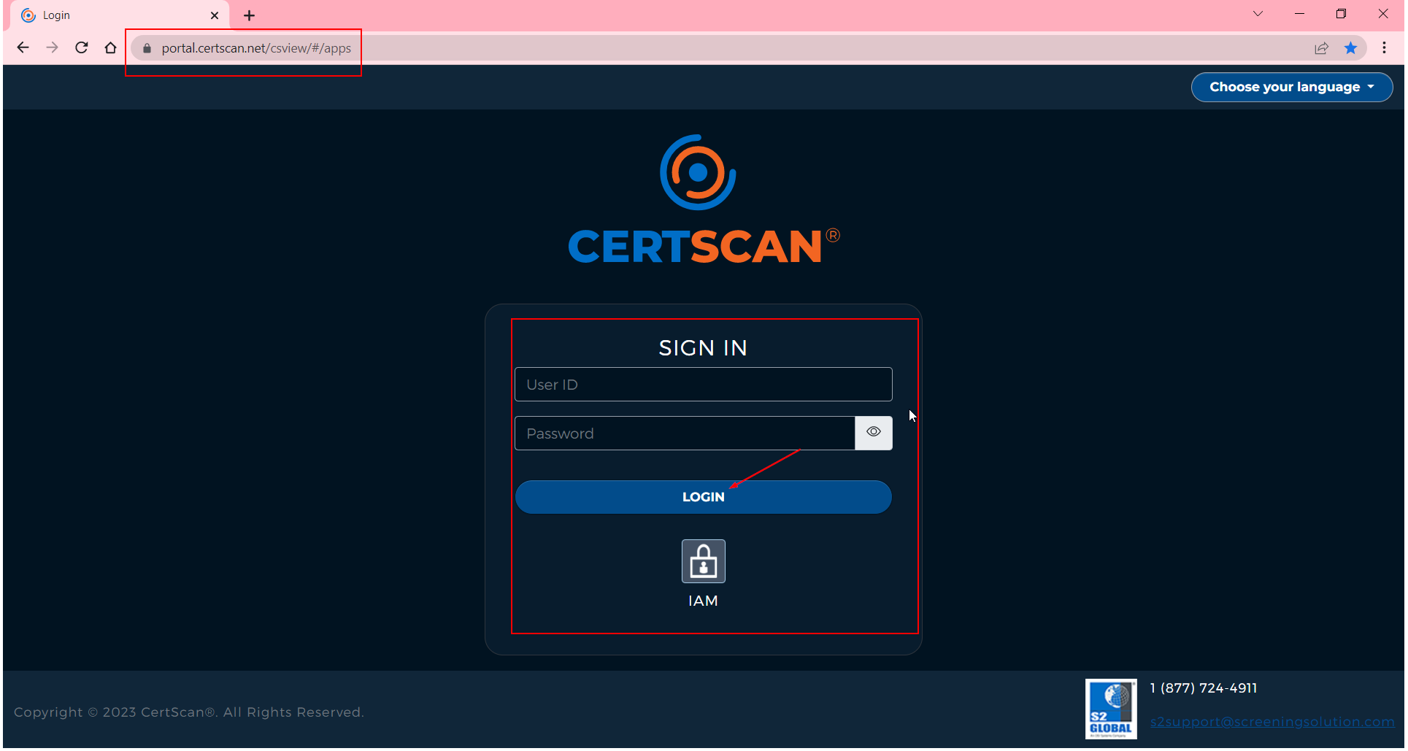

1. Logging and Monitoring (Visualization)
   1. EFG (ElasticSearch, FluentBit, and Grafana)

**Elasticsearch**is a datastore that stores data in indices. It is also a real-time scalable search engine deployed in clusters. It is utilized for storing and searching through large volume of textual data, like logs, metrics, traces, etc.

**Fluent Bit** is a super-fast, lightweight, and highly scalable logging and metrics processor and forwarder.

**Grafana** is a multi-platform open-source analytics and interactive visualization web application. It **provides charts and graphs for the application when connected to any supported data sources**.

**To visualize the Cluster Resources (CPU & Memory Utilization):**

NOTE: This process must be performed only on Master Node.

1. Run **cd ~/certscan-kubernetes-kustomize/logaggregation** command to navigate to the log aggregation folder.



1. Run **kubectl apply -k .** command to apply ElasticSearch and FluentBit.

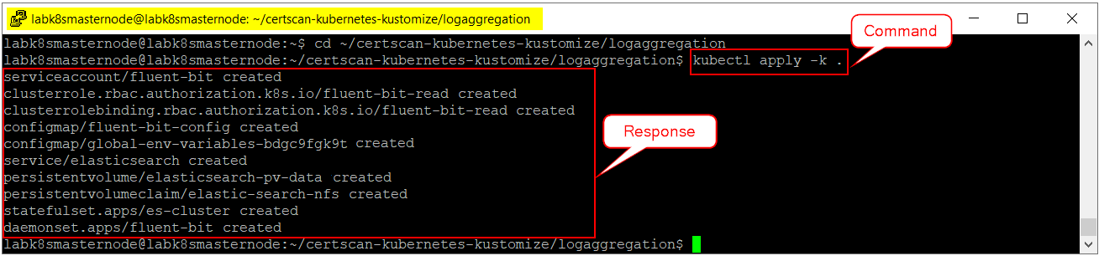

1. Run **cd ~/certscan-kubernetes-kustomize/logaggregation/prometheus-grafana-stack/manifests/setup** command to setup Prometheus and Grafana (monitoring services).



1. Run **kubectl apply -f .** command to apply monitoring services that are available in the setup folder.

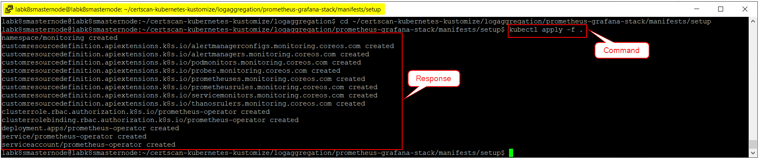

1. Run **cd ..** command to navigate back to the manifests folder.



1. Run **kubectl apply -f .** command to apply monitoring services that are available in the manifests folder.

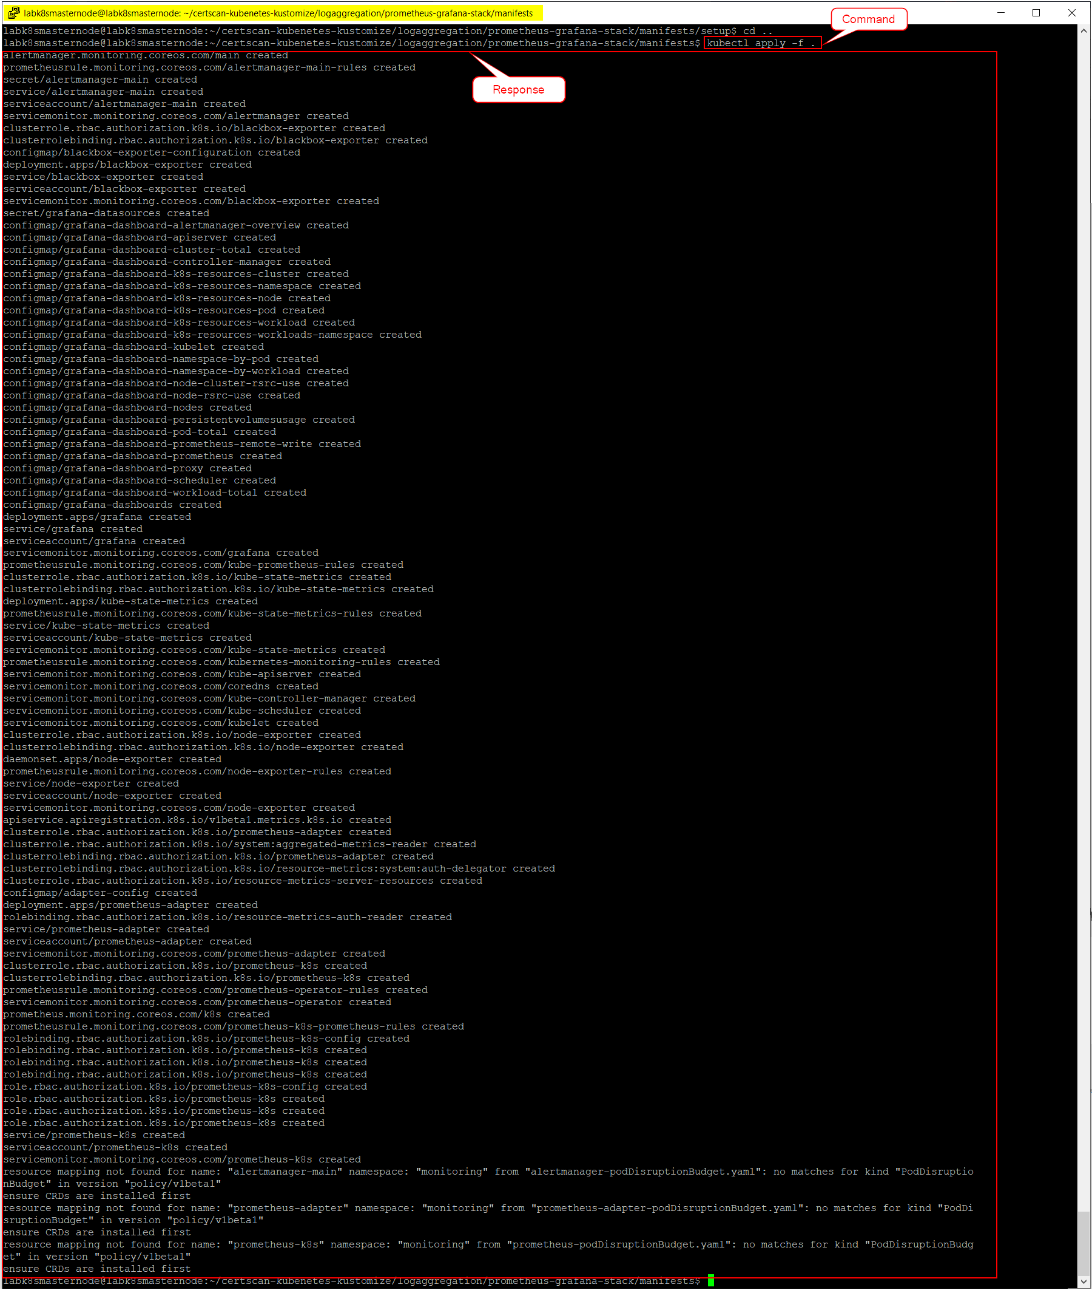

1. Run **kubectl get pod --namespace monitoring** command to verify the status of the services.

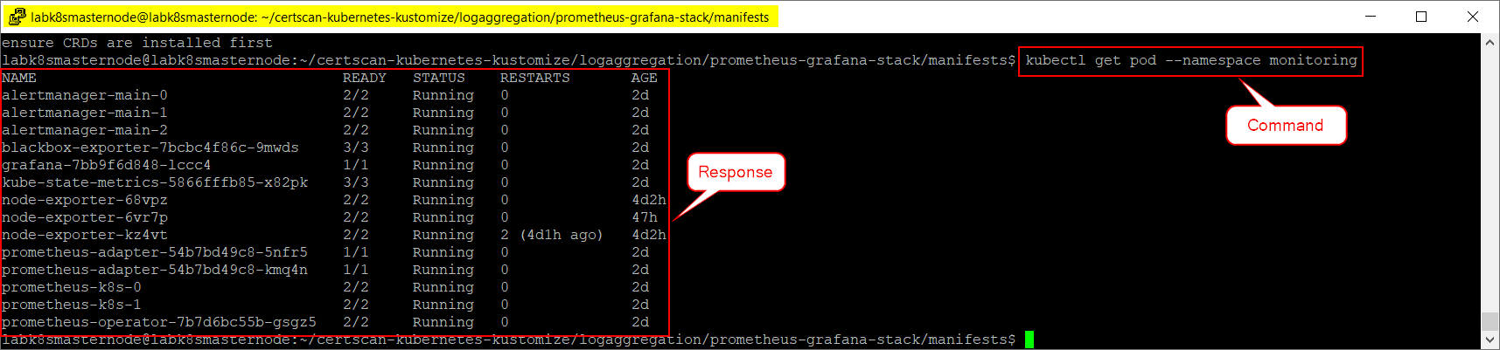

**To Access Grafana:**

1. Open Google Chrome browser.
2. Type **http://<Master Node IP Address>:30030/** URL to access Grafana application. For example, **http://10.9.204.161:30030/** is the URL because the Master Node IP address used as per this document is 10.9.204.161.
3. Login to the Grafana application by providing the following default user credentials.
   1. *Username* – admin
   2. *Password* – admin

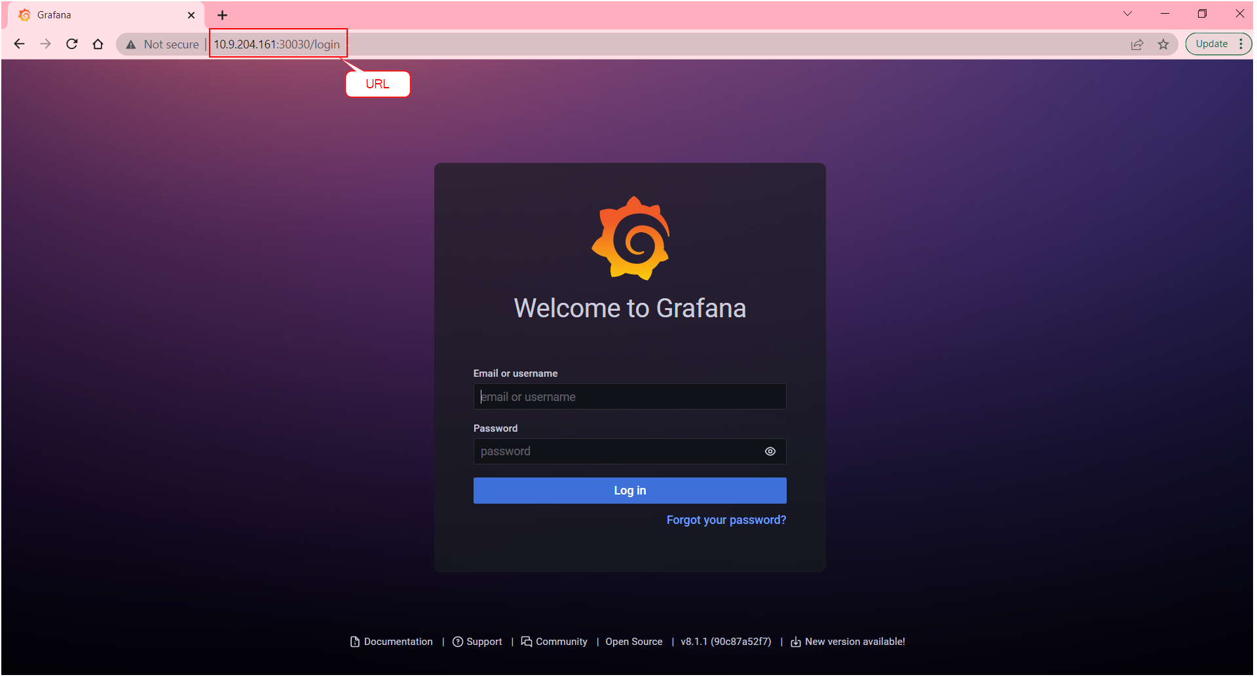

1. While logging into the application, user can either change the password or skip the activity.

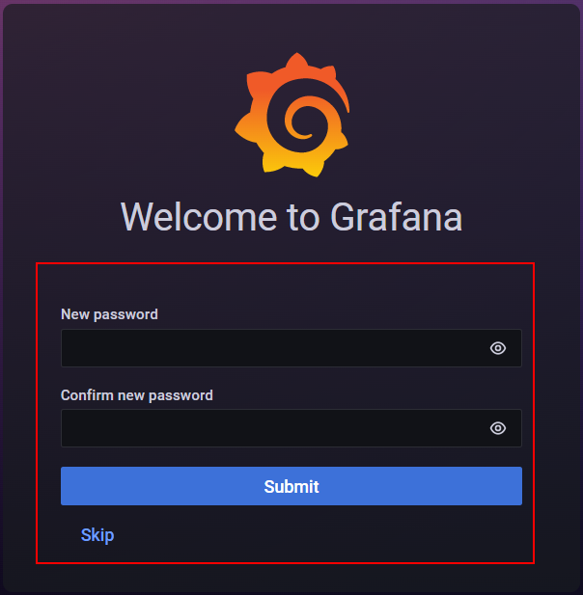

**To Check Log History in Grafana:**

1. Open Grafana application.

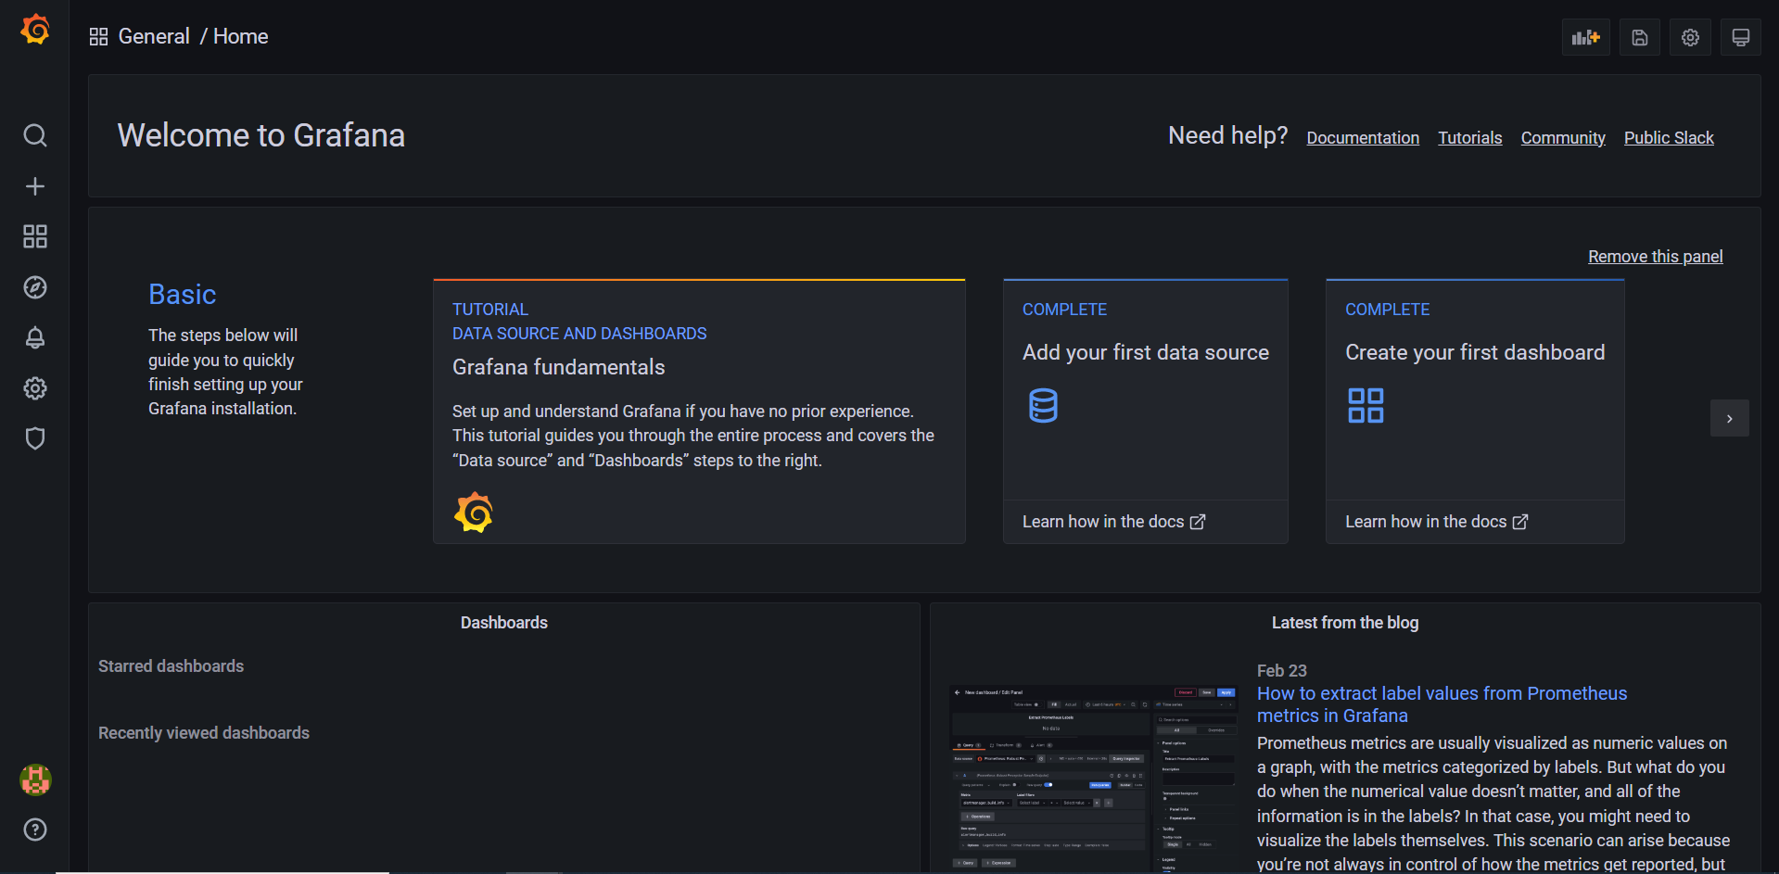

1. Go to **Settings à Data Sources** and click on **Add data source** button.

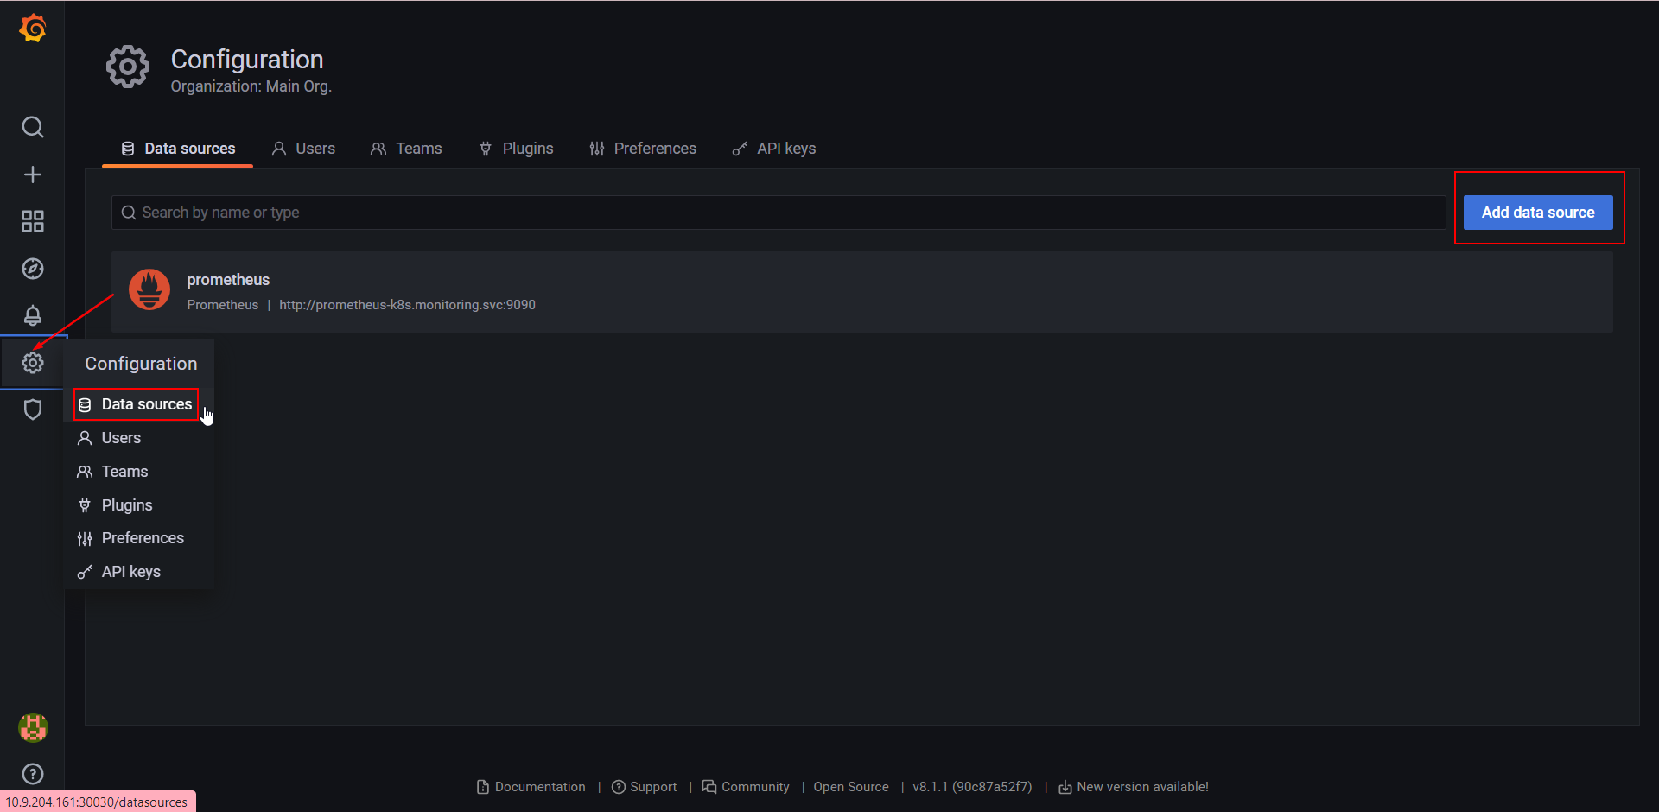

1. Look out for the ElasticSearch from the list of data sources and click on **Select** button.

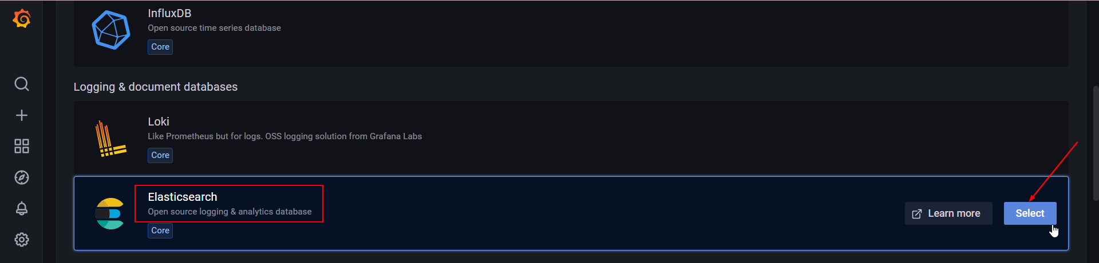

1. In ElasticSearch data source settings, update the following configurations in their respective fields as shown below.
   1. URL – **http://<Master Node IP Address>:31020**
   2. Index Name – **fluentbit**
   3. Version – **7.0+**

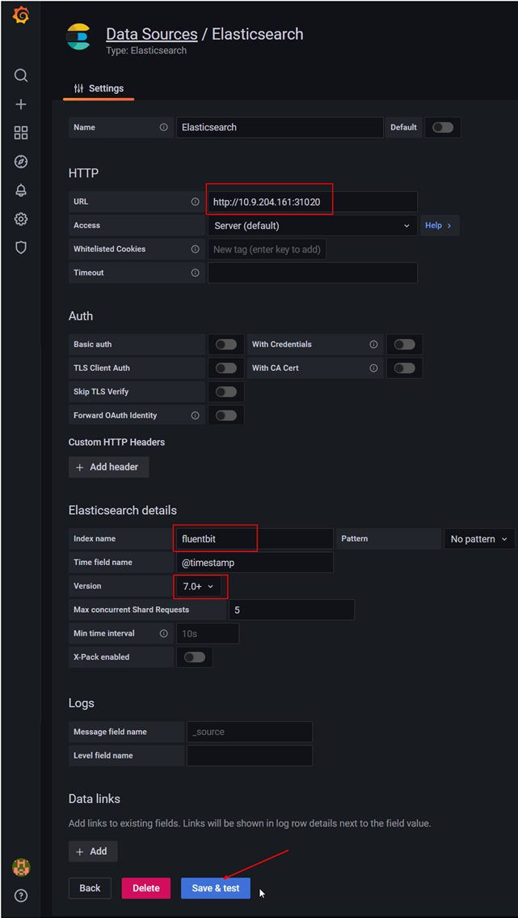

1. Click on **Save & test** button.
   1. If all the configurations are properly setup, then the Test will be passed and the following messages will be displayed on the screen.
      1. Index OK. Time field name OK.
      2. Datasource updated.

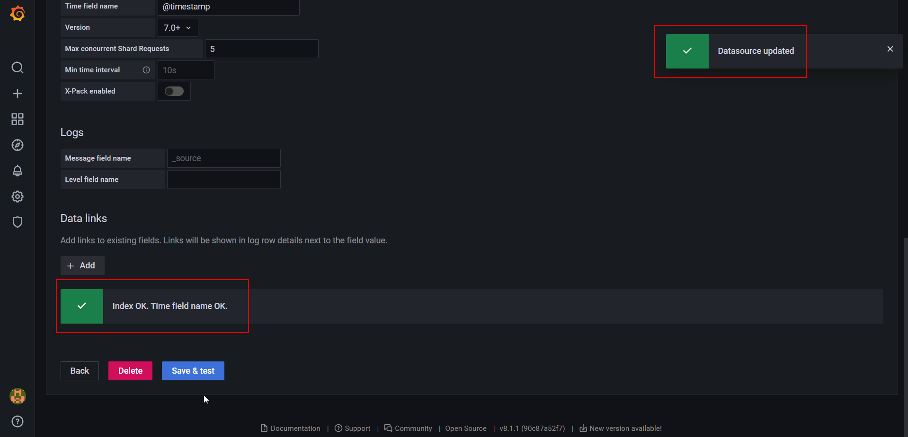

1. Go to **Menu** and click on **Explore.**

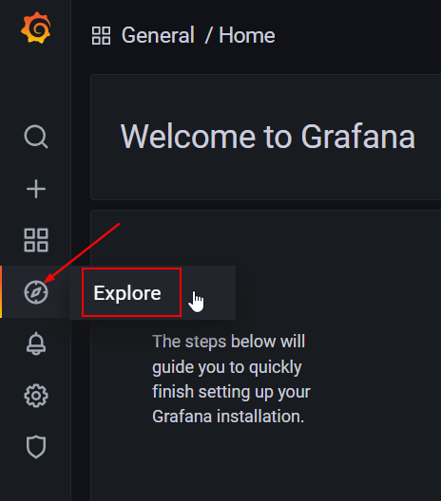

1. Select the **Elasticsearch** datasource from the dropdown list as shown below.

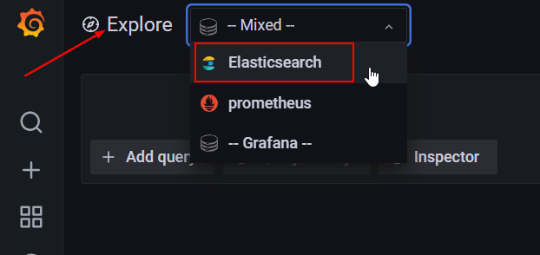

1. Click on **Metric** dropdown and select **Logs** from the list.

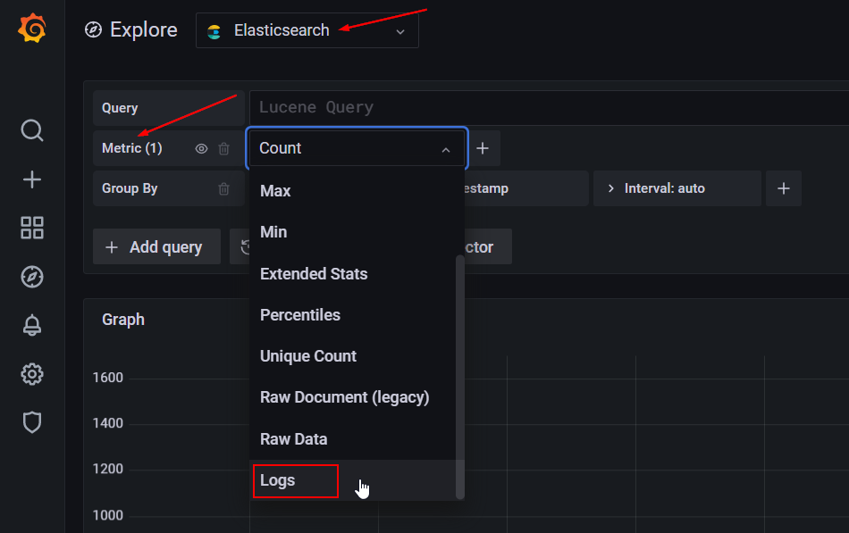

1. Once the logs are selected, all the server related logs are displayed on the screen.

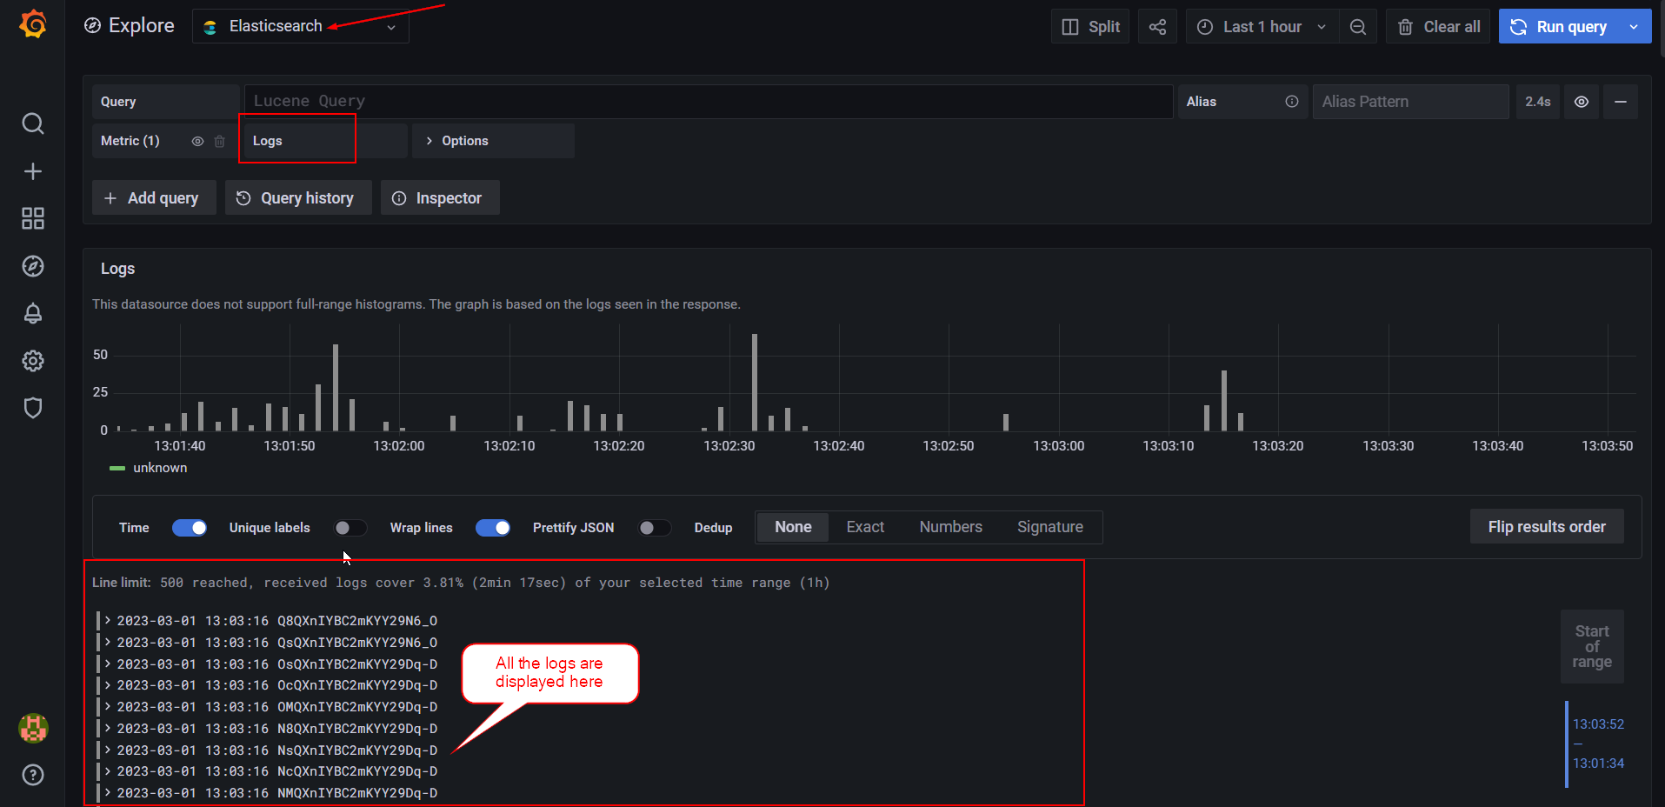

1. Certificate Update Process

NOTE: This process must be performed only on Master Node.

**To update the Certificate:**

1. Run **cd ~/convertpem** command to navigate to convertpem folder.

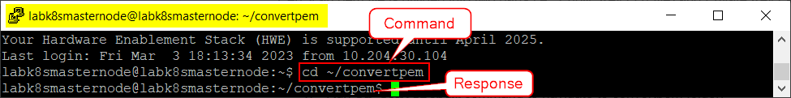

1. Run **sudo chmod +x ConverPemToK8STLSValues.sh** command to provide execution permissions to the shell script.

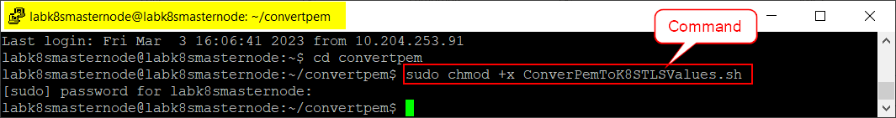

1. Run **./ConverPemToK8STLSValues.sh certscan.pem** command to execute the shell script.

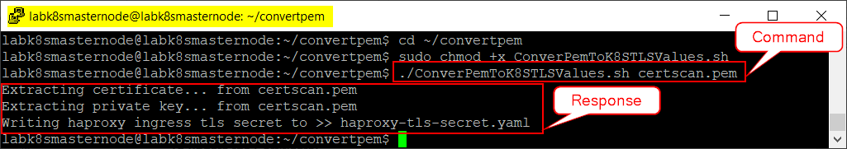

1. Run **ls** command to verify whether the haproxy-tls-secret.yaml file is generated.

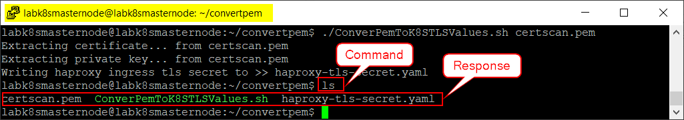

1. Run **sudo cp -rf haproxy-tls-secret.yaml /home/labk8smasternode/certscan-kubernetes-kustomize/haproxy-ingress/** command to copy the generated yaml file into certscan-kubernetes-kustomize à haproxy-ingress folder.



1. Run **cd ~/certscan-kubernetes-kustomize/haproxy-ingress/** command to navigate to haproxy directory.



1. Run **kubectl apply -k .** command to execute the haproxy-tls-secret.yaml file.

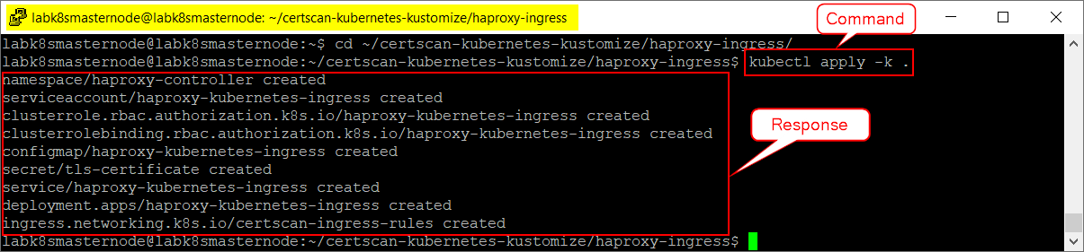

1. Open Google Chrome browser and type “<https://portal.certscan.net/csview>” URL to access CertScan application.

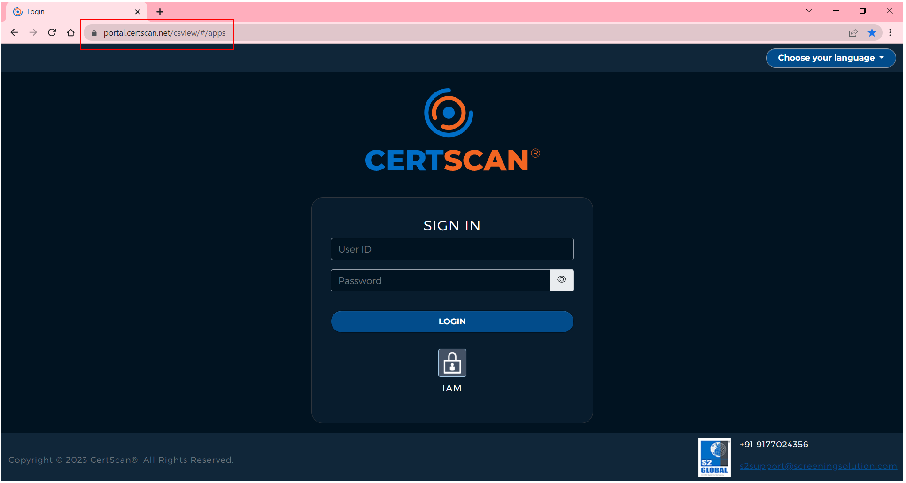

1. Click on **Lock** **Symbol** located behind the CertScan URL (as shown below) to view the site information.

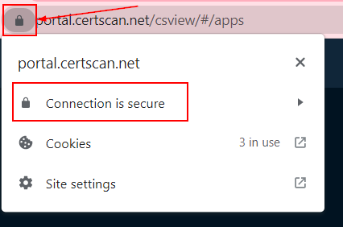

1. Click on **Connection is secure** and then click on **Certificate is valid** option.

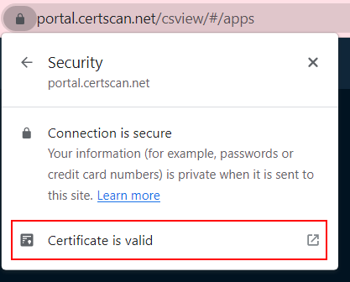

1. Verify the validity of the certificate and make sure that it is still valid from the date it is being viewed.

